
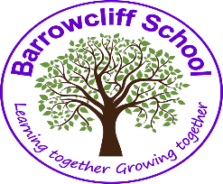



What is the Thrive Approach?
We know that children learn best in school when they are happy and settled.

At Barrowcliff we are using the Thrive Approach to help us develop our pupils’ emotional and social well-being. Thrive helps us to check children’s readiness to learn, to identify any gaps and then plan to meet them. Through doing so, we will be able to make sure that all of our pupils have what they need to make the best possible progress in their learning.
Why do some children need Thrive?
Unfortunately, (like all of us at some point in our lives), children may face challenges that knock
them off course. What is needed then is understanding and support to get them back on track. Many
children will respond to the care, understanding and support given by parents, family, friends and
teachers. However, some children need a little bit extra to enable them to:
- Feel good about themselves
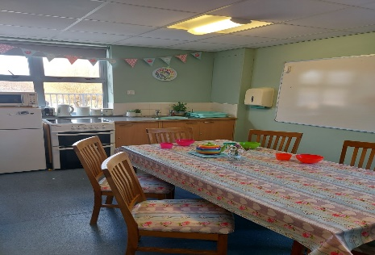
- Know that they matter
- Become more resilient and resourceful
- Have a positive place in society
- Form trusting, rewarding relationships
- Be creative
- Be compassionate and empathetic
- Be thoughtful and self-aware
- Be productive
- Be able to overcome difficulties and setbacks
THRIVE sessions for individuals or groups
The Thrive approach offers practical strategies and techniques and is built around online assessments which identify children’s emotional development and provides action plans for their individual needs. Thrive promotes children’s emotional and social growth by building positive relationships between a child and their peers and helps them explore and understand their feelings through various activities.
During each session there will be an activity which may include:
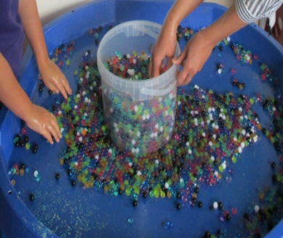
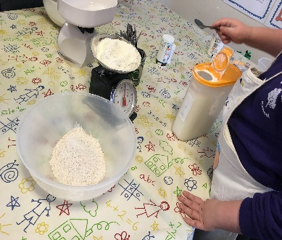
- Circle games
- Arts and crafts
- Sand play
- Movement and relaxation
- Hand and foot massage
- Cooking and preparing food
- Role play and puppet work
- Gardening

