Ongoing Weekly Science Tasks – Year 2

- Try and complete two activities per week. Pick the activity your child is interested in doing. You can record anything in your exercise book. Pictures and artwork can be stuck in their books All the activities should be attached below. If you have any difficulties please let me know by using the Class dojo app.
Science Aims:
- identify that most living things live in habitats to which they are suited and describe how different habitats provide for the basic needs of different kinds of animals and plants, and how they depend on each other
- describe how animals obtain their food from plants and other animals, using the idea of a simple food chain, and identify and name different sources of food.
Activities:

- What is a food chain? Watch the following BBC bitesize video clip and use the games to help you develop your understanding. https://www.bbc.co.uk/bitesize/topics/zx882hv/articles/z3c2xnb
- What is a rainforest habitat? Watch the video clip then test your knowledge in the fun quiz https://www.bbc.co.uk/bitesize/topics/zx882hv/articles/zxdsvcw

Challenge:
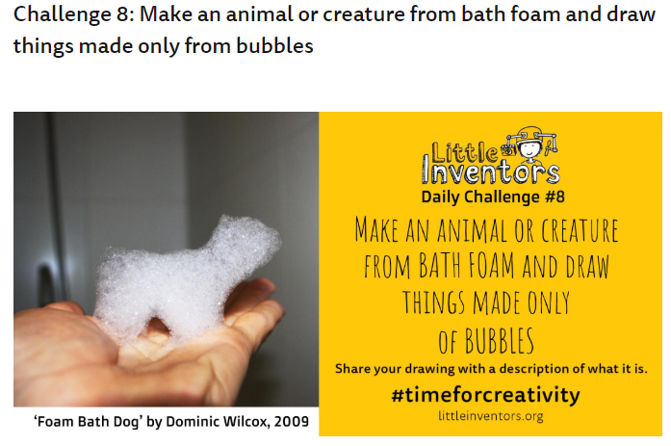

Please send photos of any completed work to share on the Class dojo app.

