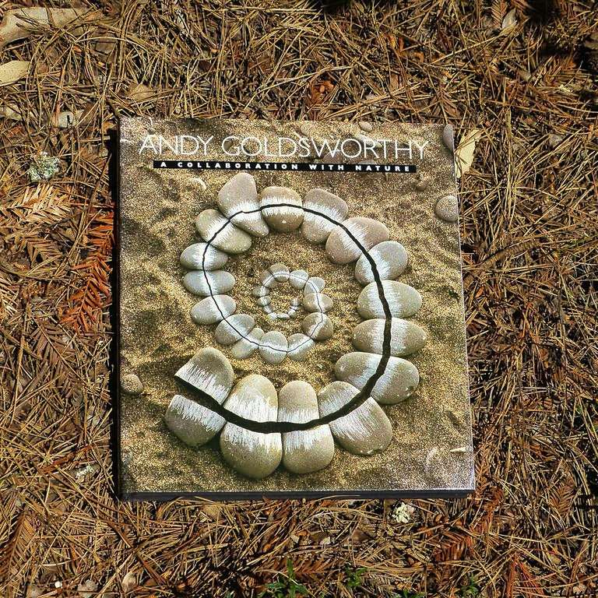
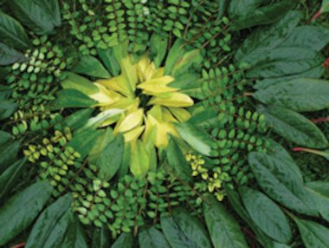
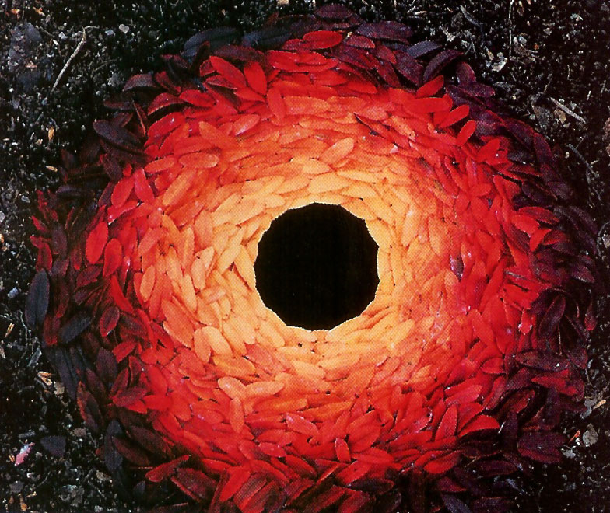
Here are some images of Andy Goldsworthy’s art to help you.
This Photo by Unknown Author is licensed under CC BY-SA-NC

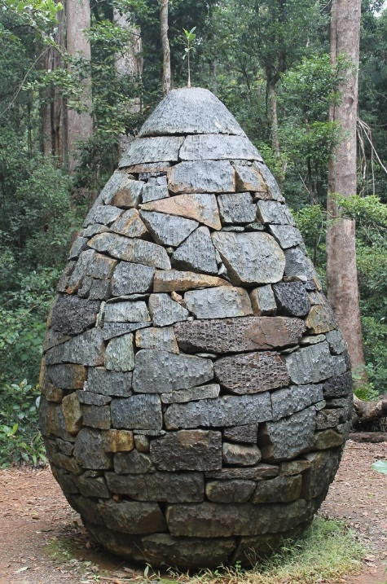
This Photo by Unknown Author is licensed under CC BY-NC-ND

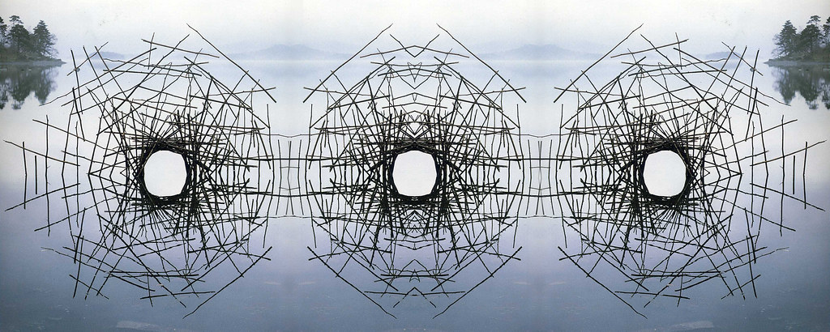
This Photo by Unknown Author is licensed under CC BY

