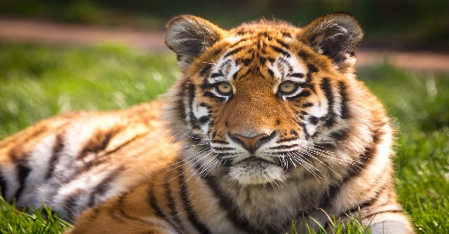
I can map information about a tiger.
This Photo by Unknown Author is licensed under CC BY-ND

