Class 3- Science (Week beginning 20.4.20)
This half term we are going to be learning about animals including humans.
Activity 1-The Human Body
Sing head, shoulders, knees and toes whilst pointing to the correct body parts.
Next, get a large piece of paper and pen or go outside with some chalk and draw around a member of your family or ask them to draw around you.
Can you label the different body parts?
You could take a photo of your diagram and send it via the dojo app so I can see how many parts you managed to label!
Scroll down for the answers below to see how many you got correct.

Activity 2- Cut and Stick the body parts
Watch the video by clicking on the link: https://www.bbc.co.uk/bitesize/topics/zfg8mp3/articles/zbxnscw
Next, follow the PDF link on the school website and cut and stick the body parts into the correct place.
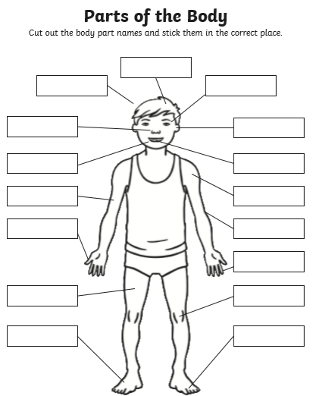

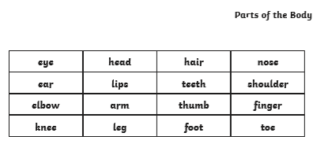

Answers
Here are the labelled parts of the human body.


