Class 3- Science (Week beginning 13.4.20)
Activity 1- Spring Walk
Go outdoors and see what signs of spring you can find! How many can you tick off your checklist?
Challenge: Can you write about what you found? What could you see, smell, hear, feel?
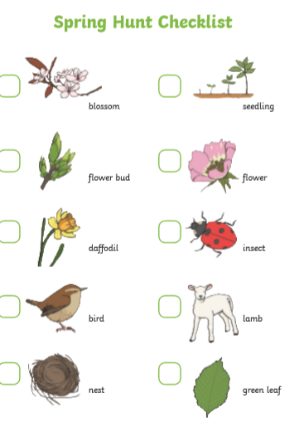

Activity 2- Bean Plant
Final week!!
Can you draw a picture and write a couple of sentences to explain what your bean plant looks like now after growing for the past month?
Date:

