Class 3- Science (Week beginning 6.4.20)
Activity 1- Life Cycle of a plant
Can you draw a diagram to show the life cycle of a plant? Use the cards below to help you.
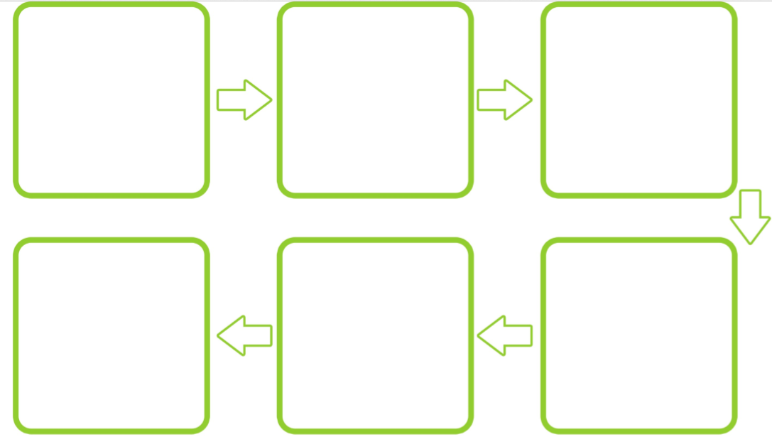

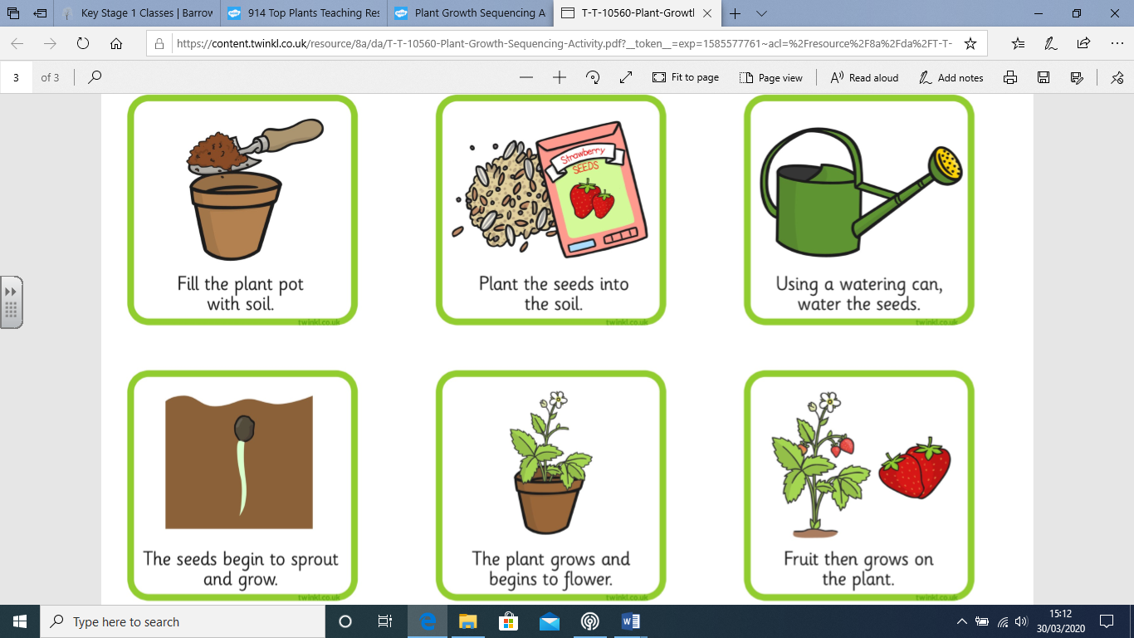

Activity 2- Bean Plant
Continue to look after your bean plant. Can you draw a picture and write a couple of sentences to explain what your bean plant looks like now?
Date:

