Class 3- Science (Week beginning 30.3.20)
Activity 1- Instruction writing
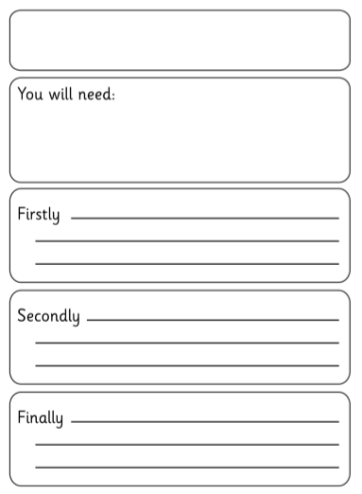
Write a set of instructions explaining how to grow a plant. Use the template below to help you.
How to grow a plant.
Activity 2- Bean Plant
Continue to look after your bean plant. Can you draw a picture and write a couple of sentences to explain what your bean plant looks like now?
Date:

