Year 2 Art

For all those budding artists out there…I have selected a range of arty activities for you do indoors or outdoors. You can use materials you have around the house. Have fun and get arty! .
Activities:
- Lots of ideas for practising drawing skills, each idea has a ‘bite-size’ video for instruction.
- https://www.bbc.co.uk/bitesize/topics/z83bkqt/resources/1

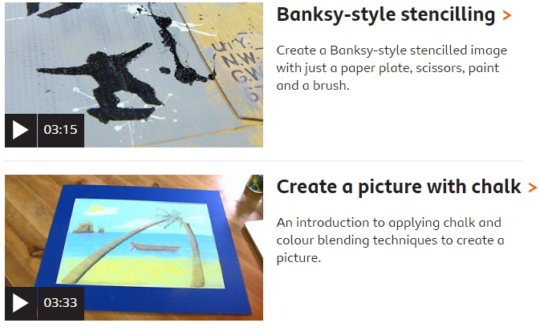
- Art projects to try at home – Top ten ideas for 7 year olds. Free lessons accompanied by a video. Pages of different art ideas covering different topics, celebrations and seasons.
https://www.deepspacesparkle.com/category/art-lessons/second-grade-art-lessons/page/5/


