Year 2 Art

For all those budding artists out there…I have selected a range of arty activities for you do indoors or outdoors. You can use materials you have around the house. Have fun and get arty! .
Activities:
- Make a landscape collage out of different materials. First watch the video. Send me a photo of your artwork on Class Dojo.
- https://www.bbc.co.uk/teach/class-clips-video/art-and-design-using-textured-materials-landscape-collage/zfrfbdm

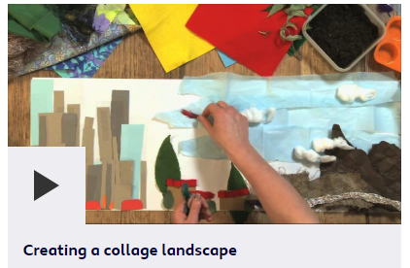
- Art projects to try at home – Top ten ideas for 7 year olds.
https://artfulparent.com/top-10-art-activities-for-kids/
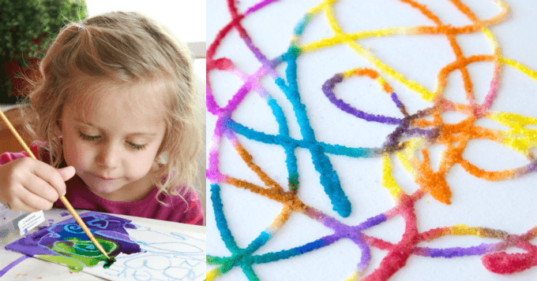
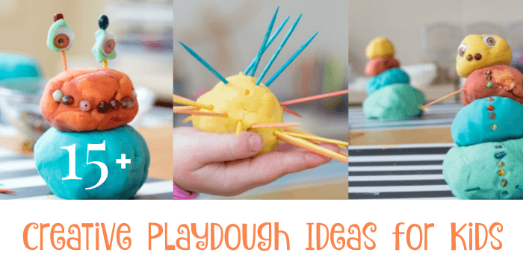

- Study the famous artist Andy Goldsworthy and recreate their painting style. Watch the video below and create a masterpiece of your own!
https://www.thenational.academy/year-2/foundation/to-investigate-the-colours-year-2-wk1-5/#

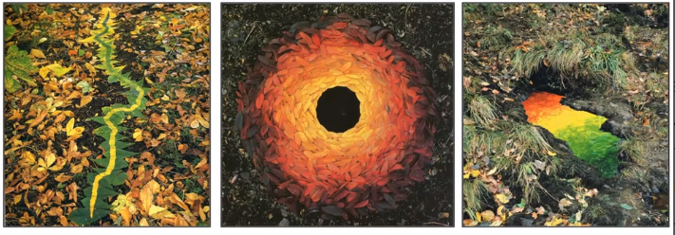

Please remember to send photographs of any artwork to the Class dojo app so that I can see it. If you cannot get on to the app please ring school and let them know so I can update your details.

