Year 2 Art

For all those budding artists out there…I have selected a range of arty activities for you do indoors or outdoors. You can use materials you have around the house. Have fun and get arty! .
Activities:
- Make a picture out of junk materials. Watch a clip from BBC Mr Maker. https://www.youtube.com/watch?v=FlYbvsvuNpM
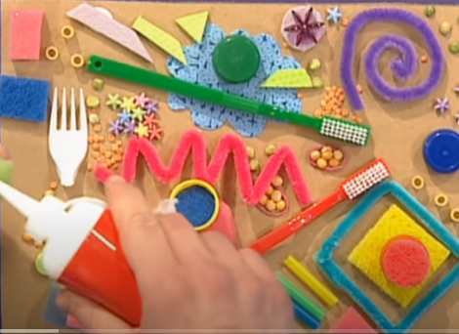

- Art projects to try at home – Top ten ideas for 7 year olds.
https://artfulparent.com/top-10-art-activities-for-kids/
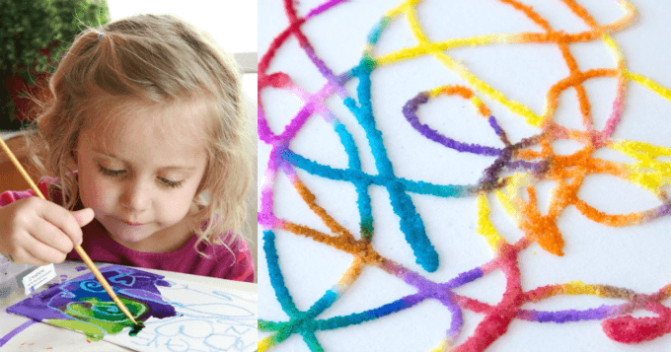
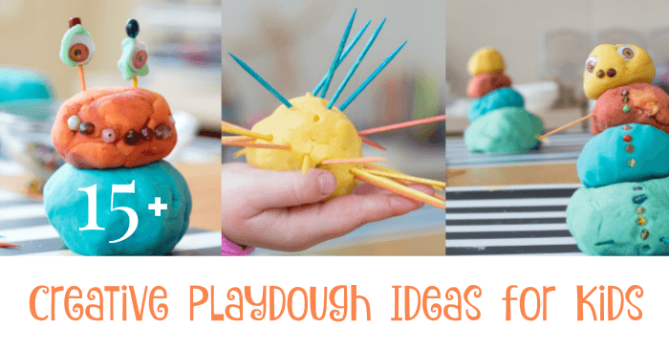

- Study a famous artist and recreate their painting style. Pick from a range of famous artists and use the step by step instructions to help you create a masterpiece of your own!
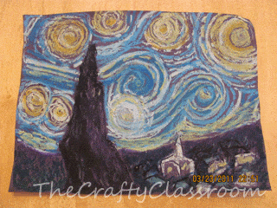
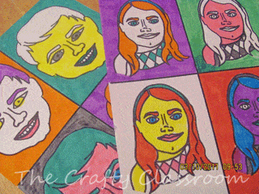
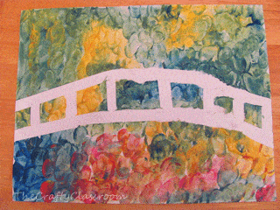

Please remember to send photographs of any artwork to the Class dojo app so that I can see it. If you cannot get on to the app please ring school and let them know so I can update your details

