Year 2 Art

For all those budding artists out there…I have selected a range of arty activities for you do indoors or outdoors. You can use materials you have around the house. Have fun and get arty! .

Activities:
- Easter art ideas. Lots of great ideas on this website with instructions. https://www.headstartprimary.com/blog/easy-easter-crafts-school/.
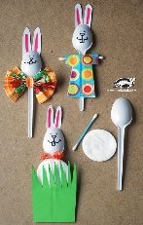
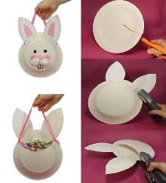
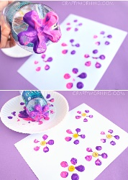
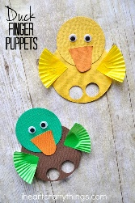
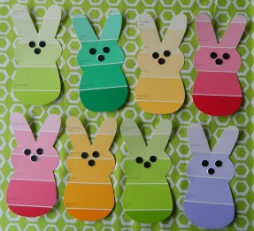

- Art ideas with nature. Time to get outside and use the natural resources around you. Brilliant and stunning ideas on this useful website: https://artfulparent.com/nature-art-for-kids/
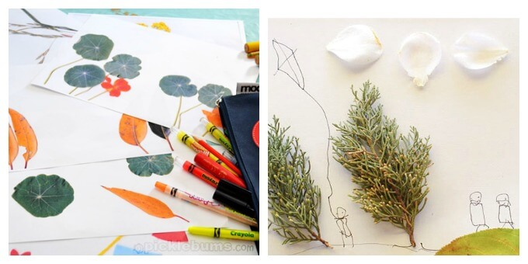
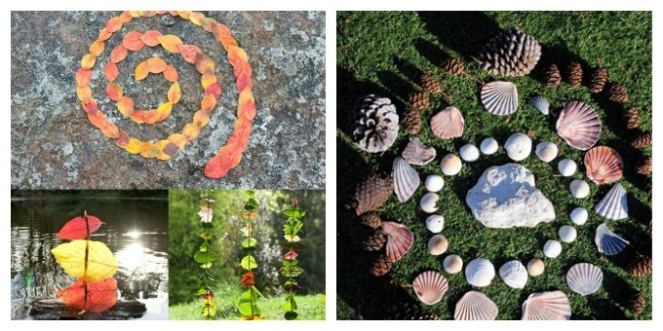

- Study a famous artist and recreate their painting style. Pick from a range of famous artists and use the step by step instructions to help you create a masterpiece of your own!
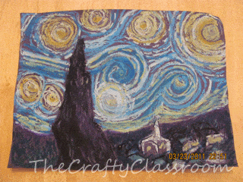
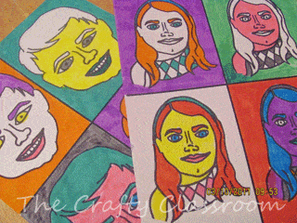
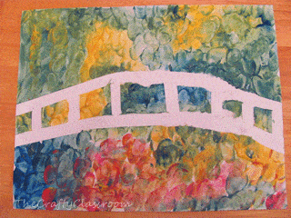

Please remember to send photographs of any artwork to the Class dojo app so that I can see it. If you cannot get on to the app please ring school and let them know so I can update your details

