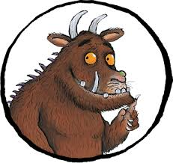
June 2020
You are learning to answer comprehension questions on the Gruffalo by Julia Donaldson
A mouse took a stroll through the deep dark wood.
A fox saw the mouse and the mouse looked good.
- Where did the mouse take a stroll?
- What did the fox see?
“Where are you going to, little brown mouse? Come and have lunch in my underground house.”
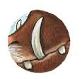
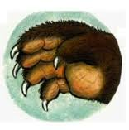
“It’s terribly kind of you, Fox, but no – I’m going to have lunch with a gruffalo.”
“A gruffalo? What’s a gruffalo?”
“A gruffalo! Why didn’t you know?”
- Who is the mouse having lunch with?
- Where does the fox live?
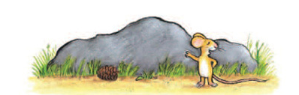
“He has terrible tusks, and terrible claws, And terrible teeth in his terrible jaws.”
“Where are you meeting him?”
“Here, by these rocks, And his favourite food is roasted fox.”
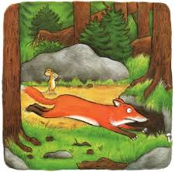
“Roasted fox! I’m off! Fox said. “Goodbye little mouse,” and away he sped.
- What does the fox look like?
- What is the Gruffalo’s favourite food?
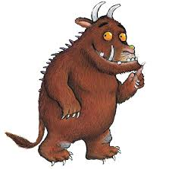
- What did the fox say to the mouse?
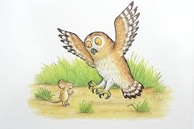

You are learning to answer comprehension questions on the Gruffalo by Julia Donaldson
A mouse took a stroll through the deep dark wood.
A fox saw the mouse and the mouse looked good.
- Where did the mouse take a stroll?
- What did the fox see?
“Where are you going to, little brown mouse? Come and have lunch in my underground house.”
“It’s terribly kind of you, Fox, but no – I’m going to have lunch with a gruffalo.”
“A gruffalo? What’s a gruffalo?”
“A gruffalo! Why didn’t you know?”
- Who is the mouse having lunch with?
- Where does the fox live?
“He has terrible tusks, and terrible claws, And terrible teeth in his terrible jaws.”
“Where are you meeting him?”
“Here, by these rocks, And his favourite food is roasted fox.”
“Roasted fox! I’m off! Fox said. “Goodbye little mouse,” and away he sped.
- What does the fox look like?
- What is the Gruffalo’s favourite food?
- What did the fox say to the mouse?
“Silly old fox! Doesn’t he know, There’s no such thing as a Gruffalo?”
On went the mouse through the deep dark wood. An owl saw the mouse and the mouse looked good. “Where are you going to, little brown mouse? Come and have lunch in my treetop house.”
- Who did the mouse meet next?
- Where does the owl live?
- What colour is the mouse?
You are learning to answer comprehension questions on the Gruffalo by Julia Donaldson
A mouse took a stroll through the deep dark wood.
A fox saw the mouse and the mouse looked good.
- Where did the mouse take a stroll?
- What did the fox see?
“Where are you going to, little brown mouse? Come and have lunch in my underground house.”
“It’s terribly kind of you, Fox, but no – I’m going to have lunch with a gruffalo.”
“A gruffalo? What’s a gruffalo?”
“A gruffalo! Why didn’t you know?”
- Who is the mouse having lunch with?
- Where does the fox live?
“He has terrible tusks, and terrible claws, And terrible teeth in his terrible jaws.”
“Where are you meeting him?”
“Here, by these rocks, And his favourite food is roasted fox.”
“Roasted fox! I’m off! Fox said. “Goodbye little mouse,” and away he sped.
- What does the fox look like?
- What is the Gruffalo’s favourite food?
- What did the fox say to the mouse?
“Silly old fox! Doesn’t he know, There’s no such thing as a Gruffalo?”
On went the mouse through the deep dark wood. An owl saw the mouse and the mouse looked good. “Where are you going to, little brown mouse? Come and have lunch in my treetop house.”
- What does the mouse call the fox?
- Who did the mouse meet next?
- Where does the owl live?
- What colour is the mouse?

“It’s frightfully nice of you, Owl, but no – I’m going to have tea with a gruffalo.”
“A gruffalo? What’s a gruffalo?”
“A gruffalo! Why didn’t you know?”
- Who is the mouse having tea with?
- Would you like to have lunch with a Gruffalo? Why?

