Class 3 – Reading and Writing (Week beginning 1.6.20)

Phonics
There will be daily Read Write Inc. phonics sessions that you can access on the following link: https://www.youtube.com/channel/UCo7fbLgY2oA_cFCIg9GdxtQ .
If you are unsure what set sounds your child is working at, please send me a message via the class dojo app. Please also encourage your child to practice spelling some of the words with the sound they have been taught. I would encourage your child to try and watch these sessions everyday.
Set 1 sounds: 9.30am
Set 2 sounds: 10.00am
Set 3 sounds: 10.30am

Reading
There are some RWInc. eBooks which your child can access and read online by following the link:
https://www.oxfordowl.co.uk/for-home/find-a-book/library-page/
Your child will be familiar with the style of these books.
Follow the link and scroll to levels > Read Write Inc level > select colour your child is working at.
Most children know what colour group they are in however, if you are unsure please send me a message via the class dojo app.
Alternatively, your child may like to choose a book they have at home to read to you. I would encourage your child to continue reading daily.

Spellings
Practice spelling this weeks’ tricky words.
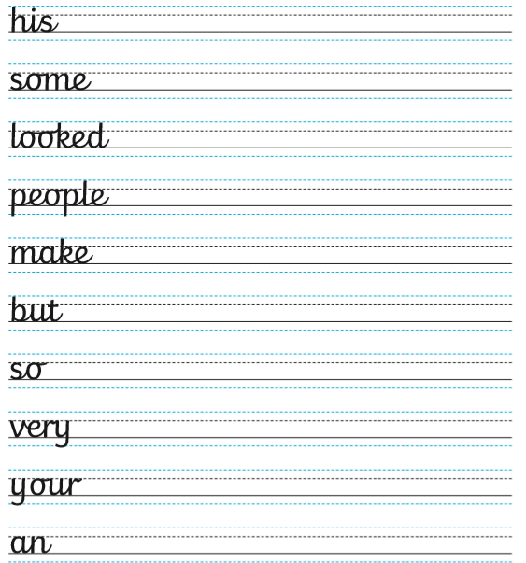

Writing
Day 1 – My Mother is a Superhero
Follow the PDF link saved on the school website, and follow the steps. There is a writing activity followed by other fun activities that you can complete if you wish.
Today’s story can be found on the PDF.

Day 2- Superheroes- All Sorts
Follow the PDF link saved on the school website, and follow the steps. There is a writing activity followed by other fun activities that you can complete if you wish.
Today’s story can be found on the school website saved under: ‘Writing Day 2 read- Superheroes- All Sorts’

Day 3- Super Daisy and the Peril of Planet Pea
Follow the PDF link saved on the school website, and follow the steps. There is a writing activity followed by other fun activities that you can complete if you wish.
Today’s story can be found on the following link:
https://www.youtube.com/watch?v=hNdKEz6p9Qg&t=2s
Day 4- Super Daisy and the Peril of Planet Pea(continued)
Follow the PDF link saved on the school website, and follow the steps. There is a writing activity followed by other fun activities that you can complete if you wish.
Today’s story can be found on the following link:
https://www.youtube.com/watch?v=hNdKEz6p9Qg&t=2s

Day 5- Super Daisy and the Peril of Planet Pea (final day)
Follow the PDF link saved on the school website, and follow the steps. There is a writing activity followed by other fun activities that you can complete if you wish.
Today’s story can be found on the following link:
https://www.youtube.com/watch?v=hNdKEz6p9Qg&t=2s

Weekly Comprehension- A trip to the zoo
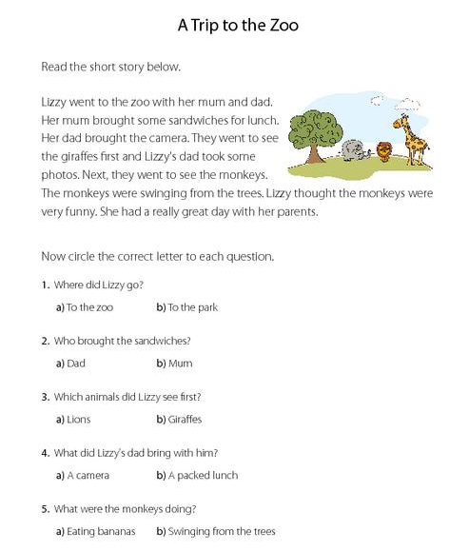
Read the passage below and then answer the questions.

