Class 3 – Maths (Week beginning 8.6.20)
Please follow the link for each day to watch the video. Once you have watched the video you can access the days worksheet from the school website.
Once you have completed the worksheet check your answers. Make any corrections if you need to.

Day 1- Count in 2’s
Watch the video on the following link, click week 7 video links > lesson 1: https://whiterosemaths.com/homelearning/year-1/
Today’s worksheet can be found on the school website under ‘Maths Day 1-count in 2’s’

Day 2- Count in 5’s
Watch the video on the following link, click week 7 video links > lesson 2: https://whiterosemaths.com/homelearning/year-1/
Today’s worksheet can be found on the school website under ‘Maths Day 2- count in 5’s’

Day 3- Count in 10’s
Watch the video on the following link, click week 7 video links > lesson 3: https://whiterosemaths.com/homelearning/year-1/
Today’s worksheet can be found on the school website under ‘Maths Day 3- Count in 10’s’.

Day 4- Add equal groups
Watch the video on the following link, click week 7 video links > lesson 4: https://whiterosemaths.com/homelearning/year-1/
Today’s worksheet can be found on the school website under ‘Maths Day 4- Add equal groups’

Day 5- Problem of the day (Sheet and answers attached below)

Day 5- Problem of the day:

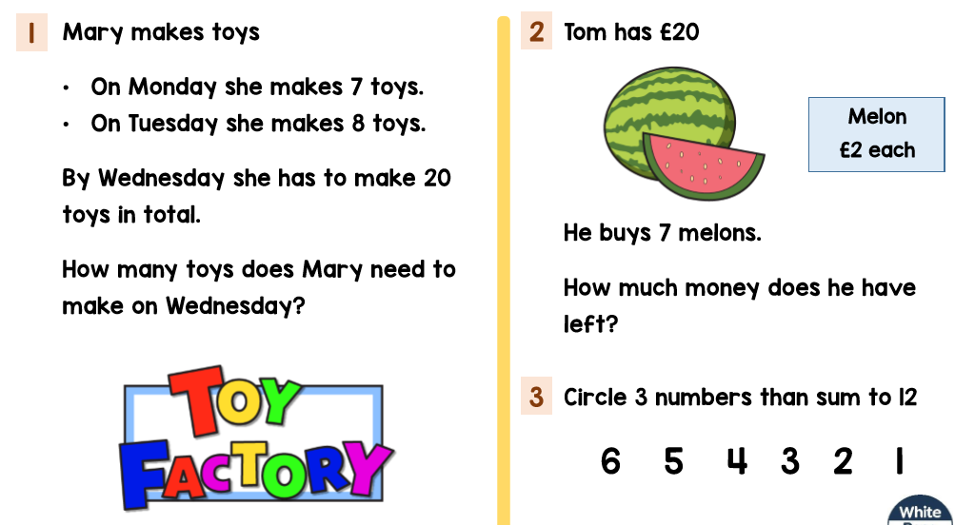

Problem of the day answers:


