Class 3 – Maths (Week beginning 1.6.20)
This week we are going to use BBC bitesize for our lessons again, a lot of the lessons are revisiting things you have already learnt.
Please follow the link under each day and complete the activities and then the worksheet.
Once you have completed the worksheet check your answers. Make any corrections if you need to.

Day 1- Measuring lengths in non-standard units of measure
https://www.bbc.co.uk/bitesize/articles/zbwc92p
Today’s worksheet can be found on the school website under ‘Maths Day 1- non-standard units of measure’

Day 2- Length and height word problems
https://www.bbc.co.uk/bitesize/articles/zrq98xs
Today’s worksheet can be found on the school website under ‘Day 2- height and length word problems’.

Day 3- Compare mass: lighter and heavier
https://www.bbc.co.uk/bitesize/articles/z428wty
Today’s worksheet can be found on the school website under ‘Day 3- heavier and lighter’

Day 4- Word problem challenge
https://www.bbc.co.uk/bitesize/articles/zhvf382
Today’s challenge questions can be found on the link- don’t worry if you find it a little tricky, just try your best!

Day 5- Problem of the day (Sheet and answers attached below)

Day 5- Problem of the day:

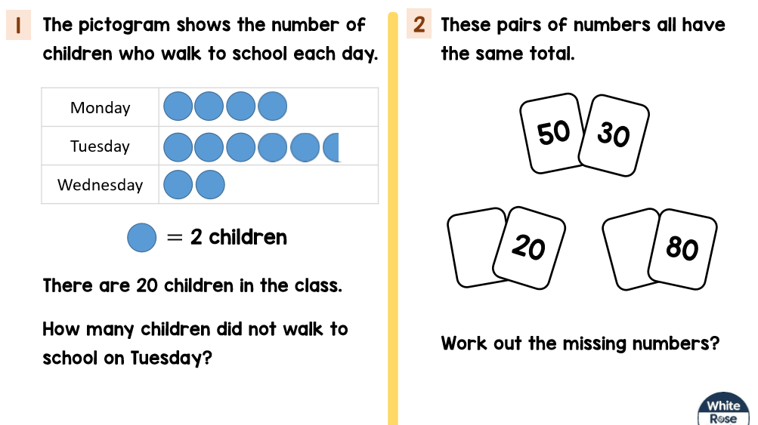

Problem of the day answers:


