Class 3 – Maths (Week beginning 25.5.20)
This week we are going to use BBC bitesize for our lessons again, a lot of the lessons are revisiting things you have already learnt.
Please follow the link under each day and complete the activities and then the worksheet.
Once you have completed the worksheet check your answers. Make any corrections if you need to.

Day 1- Subtract within 20
https://www.bbc.co.uk/bitesize/articles/zjh7mfr
Today’s worksheet can be found on the school website under ‘Maths Day 1- Subtraction within 20’

Day 2- Compare number sentences
https://www.bbc.co.uk/bitesize/articles/zmf6hbk
Today’s worksheet can be found on the school website under ‘Day 2- Compare number sentences’

Day 3- Compare length and height
https://www.bbc.co.uk/bitesize/articles/zf4vbdm
Today’s worksheet can be found on the school website under ‘Day 3- Comparing length and height’

Day 4- Word problem challenge
https://www.bbc.co.uk/bitesize/articles/z6q6pg8
Today’s challenge questions can be found on the link- don’t worry if you find it a little tricky, just try your best!

Day 5- Problem of the day (Sheet and answers attached below)

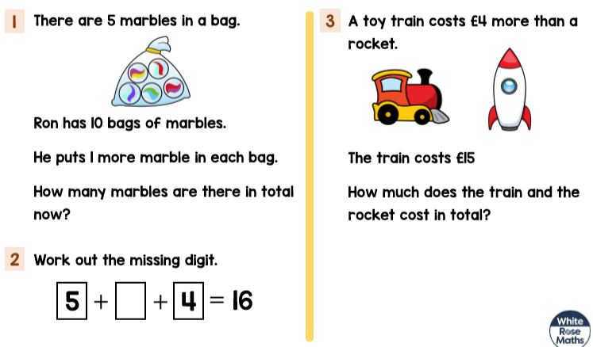
Day 5- Problem of the day:

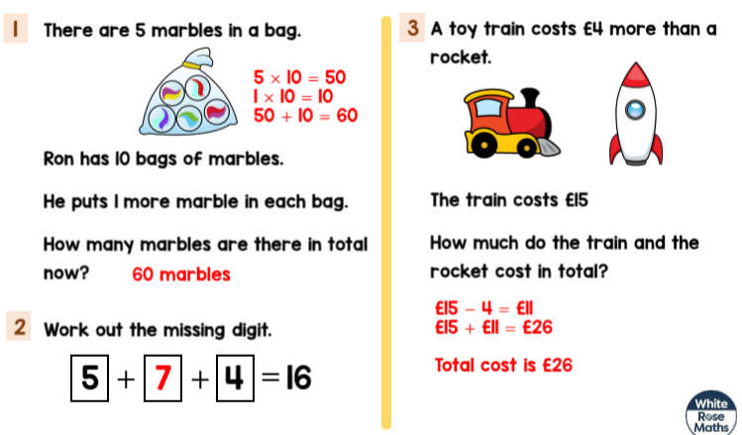
Problem of the day answers:

