Class 3 – Maths (week beginning 18.5.20)
This weeks Maths is slightly different as we are going to use BBC bitesize for our lessons.
Please follow the link under each day and complete the activities and then the worksheet.
Once you have completed the worksheet check your answers. Make any corrections if you need to.

Day 1- Partitioning numbers
https://www.bbc.co.uk/bitesize/articles/z69fy9q
Todays worksheet can be found on the school website under ‘Day 1- partitioning numbers’

Day 2- Number bonds
https://www.bbc.co.uk/bitesize/articles/zh8m6v4
Todays worksheet can be found on the school website under ‘Day 2- Number bonds’

Day 3- Fact families
https://www.bbc.co.uk/bitesize/articles/zkd98xs
Today’s worksheet can be found on the school website under ‘Day 3- Fact Families’

Day 4- Addition within 20
https://www.bbc.co.uk/bitesize/articles/zvk7mfr
Today’s worksheet can be found on the school website under ‘Day 4- Addition within 20’

Day 5- Problem of the day (Sheet and answers attached below)

Here are a list of interactive games and activities you can also keep busy with:
https://www.bbc.co.uk/teach/supermovers/ks1-maths-collection/z6v4scw
https://www.topmarks.co.uk/maths-games/5-7-years/counting
http://www.active-maths.co.uk/

Day 5- Problem of the day:

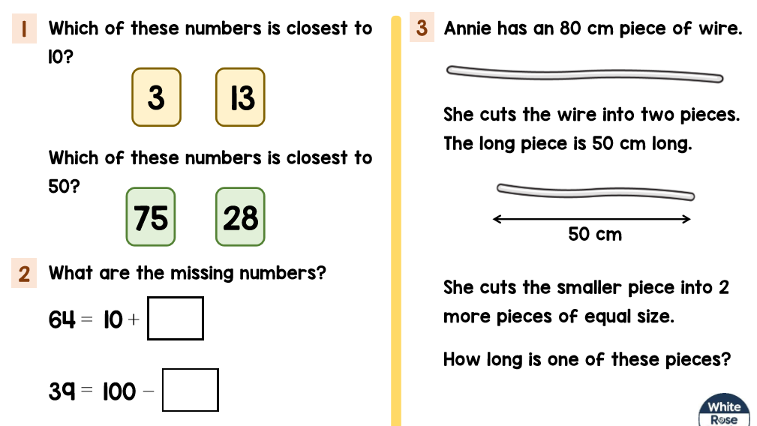

Problem of the day answers:



