Class 3 – Maths (week beginning 11.5.20)

Please access the worksheets and answer sheets online, you can access them from the school website. To do this go to the school website > Click on Class 3 Maths > Select one lesson per day.
For each lesson, watch the video online at https://whiterosemaths.com/homelearning/year-1/ (Summer Term> Week 4 w/c 11.5.20).
Once you have watched the video complete the worksheet then check your answers. Make any corrections if you need to.

Day 1- Add by making 10
Day 2- Subtraction within 20
Day 3- Add and subtract word problems
Day 4- Comparing numbers
Day 5- Problem of the day (Sheet and answers attached below)

Here are a list of interactive games and activities you can also keep busy with:
https://www.bbc.co.uk/teach/supermovers/ks1-maths-collection/z6v4scw
https://www.topmarks.co.uk/maths-games/5-7-years/counting
http://www.active-maths.co.uk/

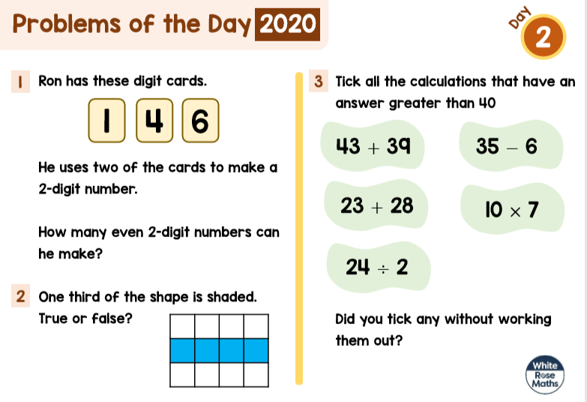

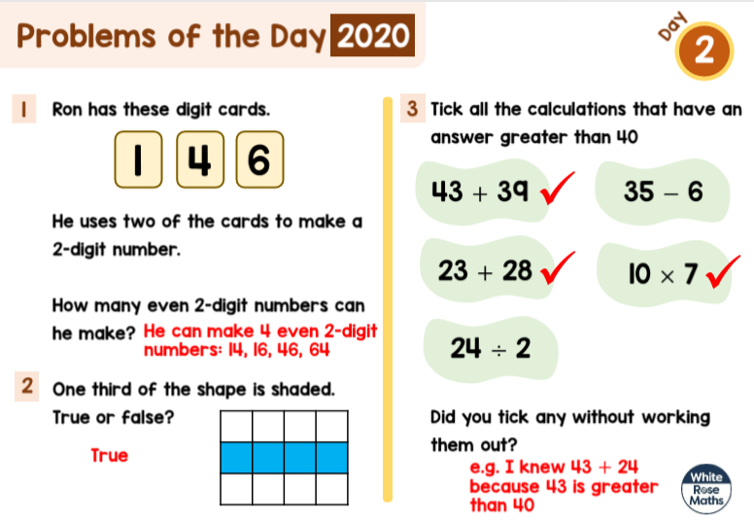
Problem of the day answers:

