Class 3 – Maths (week beginning 30.3.20)

This week we will be looking at multiplication.

Activity 1- Practice your times tables
Practice your 2, 5 and 10 times table by chanting them or by following the link: 2s- https://www.bbc.co.uk/sport/av/supermovers/42675177
5s- https://www.bbc.co.uk/teach/supermovers/ks1-maths-the-5-times-table/zhbm47h
10s- https://www.bbc.co.uk/teach/supermovers/ks1-maths-the-10-times-table-with-webster-the-spider/zm32cqt

Activity 2- Multiplication
Please watch the following video to explain how we can solve multiplication questions: https://www.youtube.com/watch?v=450YCFK4Df4
After watching this you may want to do some questions similar to the ones in the video by using practical resources (like sweets!). This will help your child understand multiplication a bit better.

Activity 3- Multiplication/repeated addition:
Complete the following questions. Use the pictures to help you if you need to. 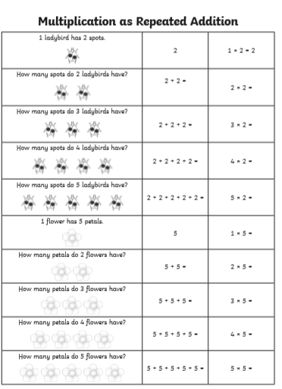

Activity 4- Word Problems
Solve the following multiplication word problems below. Remember to underline the key information in the question. You can use practical resources or draw pictures to help you.

- There are 12 sausages in 1 packet. How many are there in 2 packets?

- There are 30 children in class 3. Miss Fullerton has to mark writing and maths books tonight. How many booked does she have to mark altogether?

- In Year 2 there are 12 seats on a bus. How many seats would there be on 5 buses?

- Miss Fullerton has 24 pairs of shoes. How many shoes does she have altogether?

- There are 5 chocolate bars in a bag. How many chocolate bars would there be in 7 bags?

Activity 5- Multiplication challenge
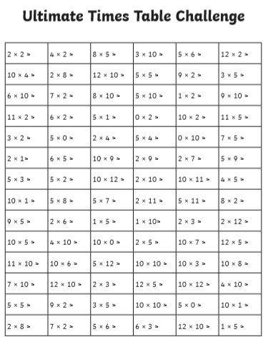
Work out the answers to the following multiplication questions for your 2, 5 and 10 times tables.

