Class 3- Topic (Week beginning 22.6.20)
This week we are going to lots of animal art!
Activity 1- Art
Follow the link and follow each instruction to learn how to draw your own Toucan!
https://www.youtube.com/watch?v=GXH9L5EBp74
For this activity you will need:
Paper
Pencil or black oil pastel
Water colours or normal crayons

Activity 2- How to draw an owl
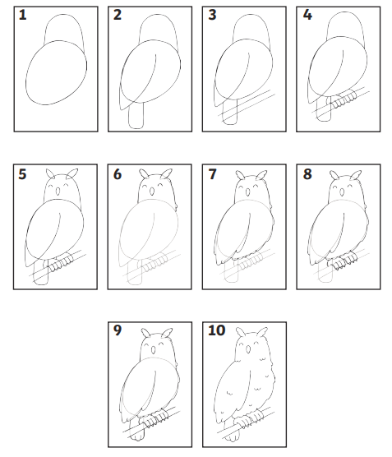
Follow the instructions to have a go drawing your own Owl, then have a go at colouring it in.

