Class 3- Topic (Week beginning 15.6.20)

Activity 1- Minibeast hotel
Follow the instructions to make your own minibeast hotel.
Remember to be gentle when picking up minibeasts to put them into your minibeast hotel.
What minibeasts do you have in your minibeast hotel?
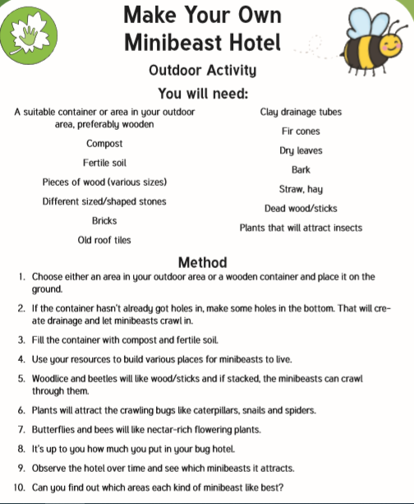

Activity 2- Minibeast Pebbles
Go outdoors and see if you can collect some stones and pebbles.
Next, go onto the school website and click on ‘Topic-Minibeast Pebbles’.
Follow the instructions to have a go at making your own minibeast pebbles.
Send pictures of your completed pebbles on the class dojo app.

