Class 3- Topic (Week beginning 25.5.20)

Activity 1- Australian animals
In Science we have been learning about Australian reptiles, however there are many more animals that come from Australia!
Look at the Australian animals PowerPoint.
Can you make a 3D model of one of the Australian animals? You could use boxes, milk cartons, cans to help you!
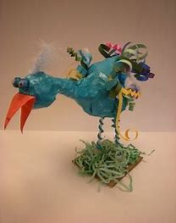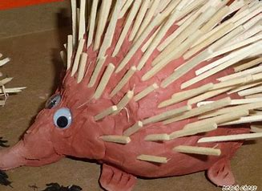

Activity 2- Aboriginal Art
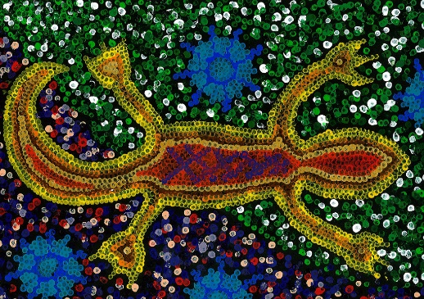
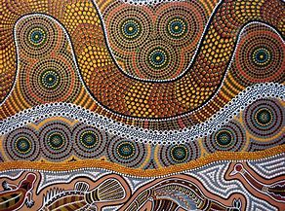
In Australia, they have a special kind of artwork called ‘Aboriginal Art’. To create these pieces of artwork they use lots of different coloured dots to create different patterns. Here are some examples:
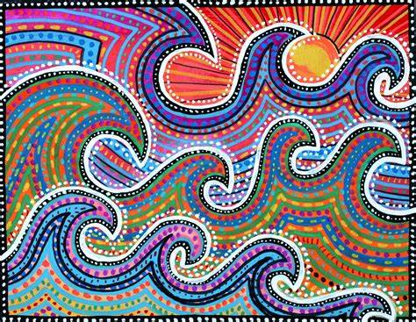
Can you create your own piece of Aboriginal art? I have attached instructions and templates for you to use on the school website. Don’t worry if you don’t have any paint to do this, felt tips or coloured crayons will work just as good!

