Class 3- Topic (Week beginning 18.5.20)

Activity 1- Arctic Animal Art
Watch the following video: https://www.youtube.com/watch?v=DXxzjmCFwTI
Next draw a picture of your favourite animals. You may want to use a variety of materials to do this such as paint, cotton wool, tissue paper etc. Be as creative as you like!
Here are some ideas below.
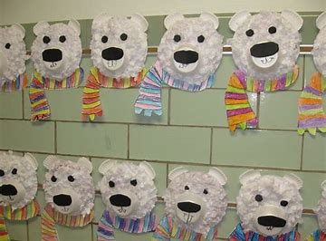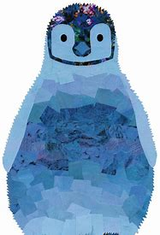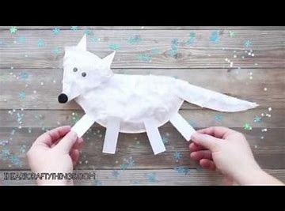

Activity 2- Arctic Animal Facts
Watch the video again: https://www.youtube.com/watch?v=DXxzjmCFwTI
Using the animal you chose to draw, find out as many facts as you can from watching the video. Write these facts on the back/underneath your picture.

