Class 3- Topic (Week beginning 11.5.20)

Activity 1- African Savannah
Watch the video to find out about animals that live in the African Savannah: https://www.youtube.com/watch?v=DnSTLQB__FY
Choose an animal and find out as many facts as you can. Create a fact file about your animal. Below is an example of how you may set it out.
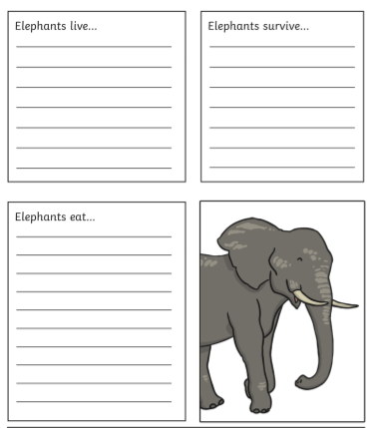
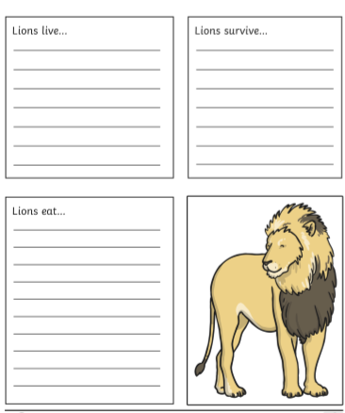

Activity 2- African Art
Create a landscape of the African Savannah. Use the pictures below to help you.
You could use paint, felt tips or use collaging to create your landscape. Get as creative as possible!


