Class 3- Topic (Week beginning 20.4.20)

Activity 1- Research using non-fiction texts
Explain that a non-fiction text tells us information about something.
Use the websites below to find out some facts about the human body. When you find out some interesting facts make some notes of what they are, you will need these notes for the next activity.
https://www.natgeokids.com/nz/discover/science/general-science/15-facts-about-the-human-body/
https://www.scienceforkidsclub.com/human-body.html
https://parenting.firstcry.com/articles/20-interesting-human-body-facts-for-kids/
https://mocomi.com/human-body-facts/
https://www.youtube.com/watch?v=sOFQHqdpxQg
https://www.youtube.com/watch?v=uKkb0iFml8w

Activity 2- Fact File
Create a fact file/poster to explain some interesting facts about the human body by using the notes you wrote. Your fact file/poster should provide information, so that other people can find out new things.
In your fact file/poster, you may want to write some facts out and maybe draw some pictures too.
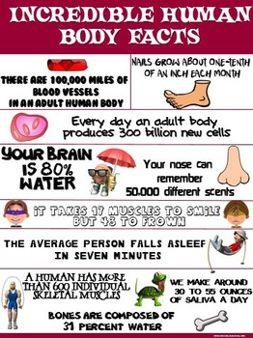
Here are some examples to help you to get started:


