Class 3- Topic (Week beginning 13.4.20)
Activity 1- Draw a landscape
Can you go outside and draw a landscape?
Begin by drawing your landscape with pencil, then add some colour!
Here are some examples of what a landscape drawing looks like.

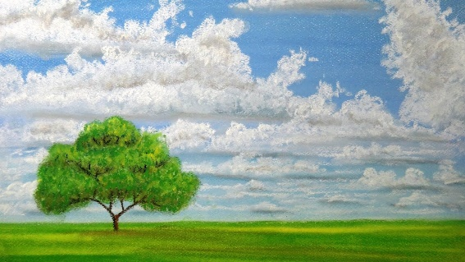
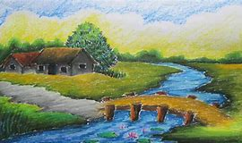

Activity 2- Weather diary
Can you keep a weather diary over the next week? Draw a picture and write a sentence explaining what the weather is like.
You may want to set it out using the template below:
Date:

Picture:

Today the weather is…

