Class 3- Topic (Week beginning 6.4.20)
Activity 1- Easter Story
Watch the video of the Easter story by following the link: https://www.youtube.com/watch?v=Wnbo2AmS3OI
Can you create a storyboard to show each part of the Easter story? Draw a picture in each box to show each part of the story.
1.
2.
3.

6.
5.
4.

Activity 2- Easter crafts
Time to get creative! Can you design an Easter bonnet, basket, card or egg? Look at the following pictures below to help get you started. You can choose any materials you want to use for your creation.
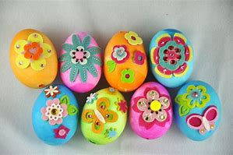
Send me your creations via the class dojo app!


