Class 3- Topic (Week beginning 30.3.20)
Activity 1- Plant hunt
Go outdoors and see what plants you can find. Can you draw a picture of the plants you find and label the different parts?

Activity 2- Outdoor art
Go outdoors and see what natural resources you can find for example: leaves and sticks. Can you create a piece of artwork or a picture with the things that you have found? Take a picture and send your creations to me on the class dojo app!
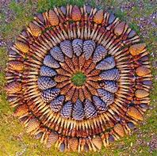
Here are some examples:


