Class 6 – English
Week beginning 13th July 2020

Weekly spellings

Use the grid below to practise your spellings. Tick the columns as you follow the instructions from left to right. Make sure you spell the words in the column that is titled ‘write’. If you spell the word incorrectly write it again in the ‘correction’ column.
 | Look | Say | Cover | Write | Check | Correction
misspell

mislead

mistreat

misbehave

mistrust

misprint

misuse

misplace

misheard

misread

Challenge – can you put each word in a sentence? If you are unsure of the meaning of any of the words the online dictionary on this website is really useful https://kids.wordsmyth.net/

Weekly English
This week you have the Talk for Writing booklet ‘Unicorns Uncovered’. You do not need to print out the booklets – just complete any tasks on paper.

Work through the booklet over the course of the week.

Reading
Please continue to read daily. If you have read all of the book that you brought home from school you can get lots of free e-books on the website:
https://www.oxfordowl.co.uk/for-home/find-a-book/library-page/#
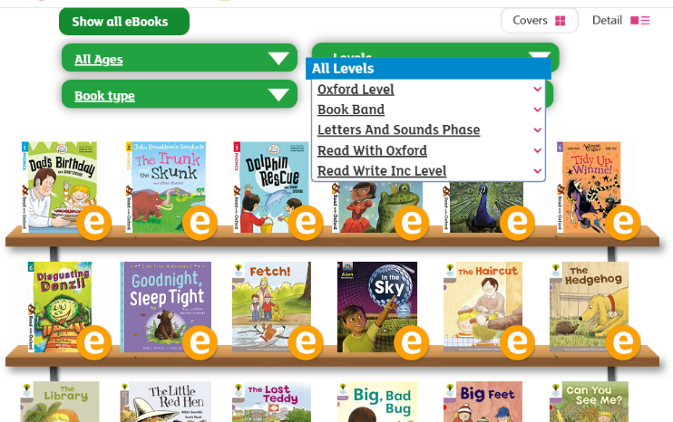
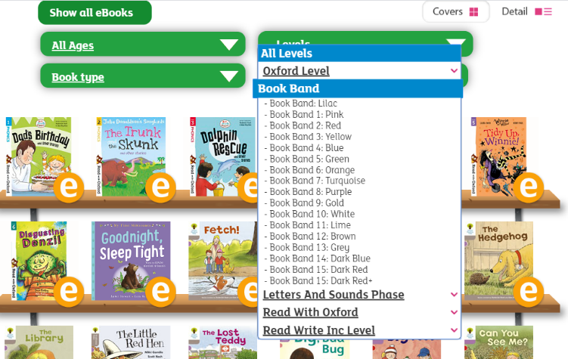
On this page, click where it says ‘levels’. This will open a drop-down menu – choose ‘book bands’ and then you should be able to click on your colour book band to see all the appropriate books.

Reading Comprehension
Each week I will also set a reading comprehension for you to do. It is really important that we keep practising using our comprehension skills as we have been working really hard on these. This week’s reading is an information text about Adaptations.

Read Write Inc Phonics
Daily Read Write Inc lessons restart this week on YouTube – we are focussing on Set 3 sounds, all lessons are now available at 9am each weekday morning.
https://www.youtube.com/channel/UCo7fbLgY2oA_cFCIg9GdxtQ/videos
It will be really beneficial if your child can watch these as it will have a really positive impact on their reading and writing once we are back at school.

I hope you all have a lovely summer – I have added a summer maths and English booklet to this week’s home learning for if you want to carry on doing some activities during the holiday but don’t feel like you have to.

Have fun, stay safe and I will hopefully see you all in September.

Mrs Meade

