Class 6 – English
Week beginning 6th July 2020

Weekly spellings

Use the grid below to practise your spellings. Tick the columns as you follow the instructions from left to right. Make sure you spell the words in the column that is titled ‘write’. If you spell the word incorrectly write it again in the ‘correction’ column.
 | Look | Say | Cover | Write | Check | Correction
forgetting

forgotten

beginning

beginner

preferred

preferring

occurred

occuring

forbidden

committed

Challenge – can you put each word in a sentence? If you are unsure of the meaning of any of the words the online dictionary on this website is really useful https://kids.wordsmyth.net/

Weekly English
This week we are continuing with the Talk for Writing booklet ‘Journey to the Jungle’ which you started last week. You do not need to print out the booklets – just complete any tasks on paper.

Monday
Re-read your plan from last week. Use the instructions on page 14 to write your own log.
Tuesday
Read the instructions ‘How to uncover a Soupee bird’ on pages 15&16. Complete the ‘Let’s Innovate’ task on page 16 and the ‘Design Challenge’ which goes onto page 17.
Wednesday
Read the information about writing your own instructions on page 17 and use the planner on page 18 to plan your own set of instructions.
Thursday
Use your plan from yesterday to write your instructions.
Friday
Complete one of the extra writing challenges on page 19.

Reading
Please continue to read daily. If you have read all of the book that you brought home from school you can get lots of free e-books on the website:
https://www.oxfordowl.co.uk/for-home/find-a-book/library-page/#
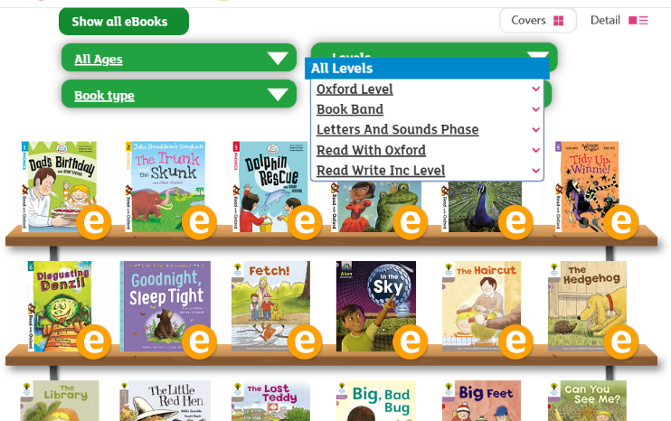
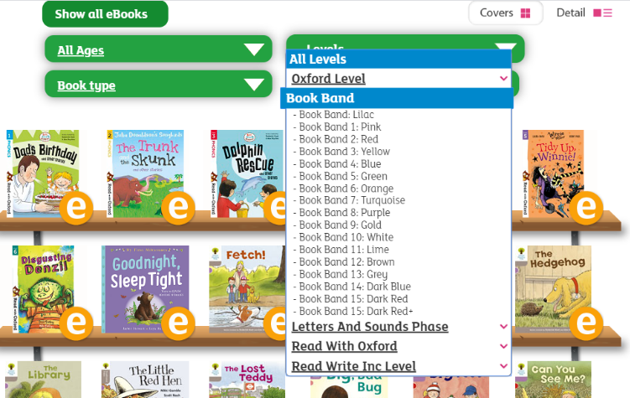
On this page, click where it says ‘levels’. This will open a drop-down menu – choose ‘book bands’ and then you should be able to click on your colour book band to see all the appropriate books.

Reading Comprehension
Each week I will also set a reading comprehension for you to do. It is really important that we keep practising using our comprehension skills as we have been working really hard on these. This week’s reading is an information text about British Coastlines.

Read Write Inc Phonics
Daily Read Write Inc lessons restart this week on YouTube – we are focussing on Set 3 sounds, all lessons are now available at 9am each weekday morning.
https://www.youtube.com/channel/UCo7fbLgY2oA_cFCIg9GdxtQ/videos
It will be really beneficial if your child can watch these as it will have a really positive impact on their reading and writing once we are back at school.

