Class 6 – English
Week beginning 29th June 2020

Weekly spellings

Use the grid below to practise your spellings. Tick the columns as you follow the instructions from left to right. Make sure you spell the words in the column that is titled ‘write’. If you spell the word incorrectly write it again in the ‘correction’ column.
 | Look | Say | Cover | Write | Check | Correction
gardener

gardening

limited

limiting

offering

offered

benefited

benefiting

focused

focusing

Challenge – can you put each word in a sentence? If you are unsure of the meaning of any of the words the online dictionary on this website is really useful https://kids.wordsmyth.net/

Weekly English
This week we are going to be using the Talk for Writing booklet ‘Journey to the Jungle’ this week and next week. You do not need to print out the booklets – just complete any tasks on paper.

Monday
Read the text on pages 2&3 and the glossary on page 4. Complete the glossary activity on page 4 and the activities on pages 5&6.
Tuesday
Re-read the log and complete the comprehension activity on page 7.
Wednesday
Use pages 8&9 to plan and write your own list poem.
Thursday
Use page 10 to create your own jungle and begin to plan your log on page 11.
Friday
Complete the grammar activities on pages 12&13.

Reading
Please continue to read daily. If you have read all of the book that you brought home from school you can get lots of free e-books on the website:
https://www.oxfordowl.co.uk/for-home/find-a-book/library-page/#
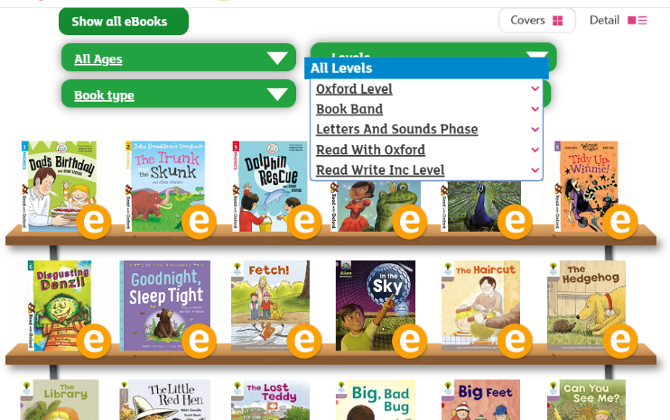
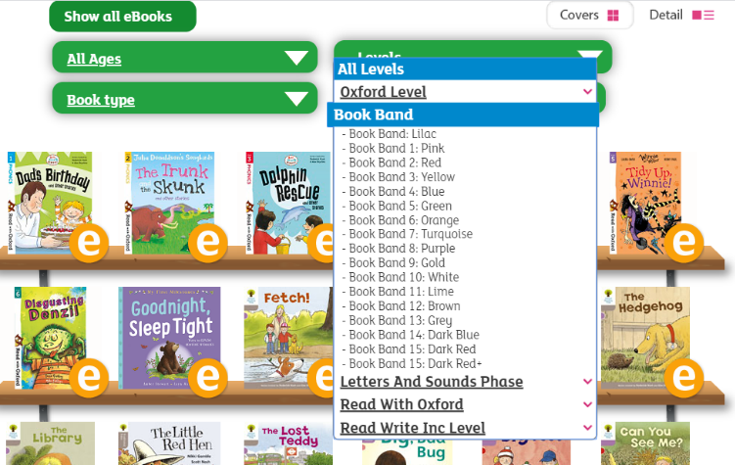
On this page, click where it says ‘levels’. This will open a drop-down menu – choose ‘book bands’ and then you should be able to click on your colour book band to see all the appropriate books.

Reading Comprehension
This week the reading comprehension is Tuesday’s lesson from the ‘Journey to the Jungle’ booklet that you are completing.

Read Write Inc Phonics
Daily Read Write Inc lessons restart this week on YouTube – we are focussing on Set 3 sounds, all lessons are now available at 9am each weekday morning.
https://www.youtube.com/channel/UCo7fbLgY2oA_cFCIg9GdxtQ/videos
It will be really beneficial if your child can watch these as it will have a really positive impact on their reading and writing once we are back at school.

