Class 6 – English
Week beginning 22nd June 2020

Weekly spellings
This week your spellings are words with a short /i/ sound that is spelt with a ‘y’.

Use the grid below to practise your spellings. Tick the columns as you follow the instructions from left to right. Make sure you spell the words in the column that is titled ‘write’. If you spell the word incorrectly write it again in the ‘correction’ column.
 | Look | Say | Cover | Write | Check | Correction
myth

gym

Egypt

pyramid

mystery

hymn

system

symbol

lyric

typical

Challenge – can you put each word in a sentence? If you are unsure of the meaning of any of the words the online dictionary on this website is really useful https://kids.wordsmyth.net/

Weekly English
This week we are going to be using the Talk for Writing booklet ‘The Truth about Trolls’. You do not need to print out the booklets – just complete any tasks on paper.

Monday
Read the text about trolls on pages 3-5 and the glossary on page 6. Complete the grammar activities on pages 7, 8 & 9.
Tuesday
Complete the adverb activities on pages 10 & 11.
Wednesday
Play the Engaging Adverbs game on page 12 and the Drop-in game on page 13.
Thursday
Read about the underlying structure on page 14 and then use the planner on page 15 to jot some ideas down for your own information text about trolls.
Friday
Read the instructions on page 16 about writing your own text and then have a go at writing it!

Reading
Please continue to read daily. If you have read all of the book that you brought home from school you can get lots of free e-books on the website:
https://www.oxfordowl.co.uk/for-home/find-a-book/library-page/#
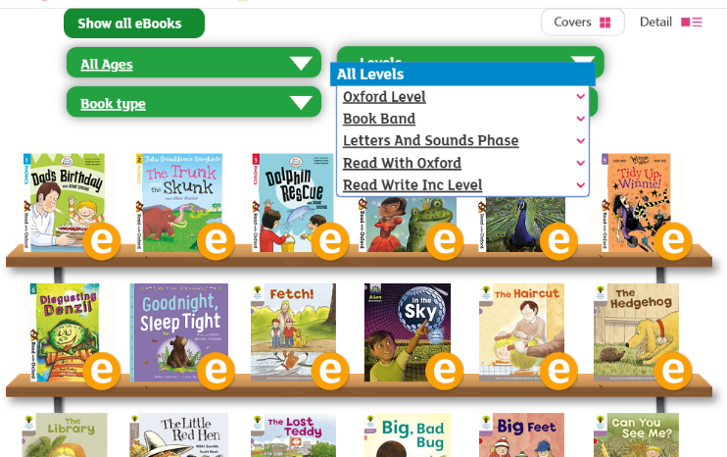
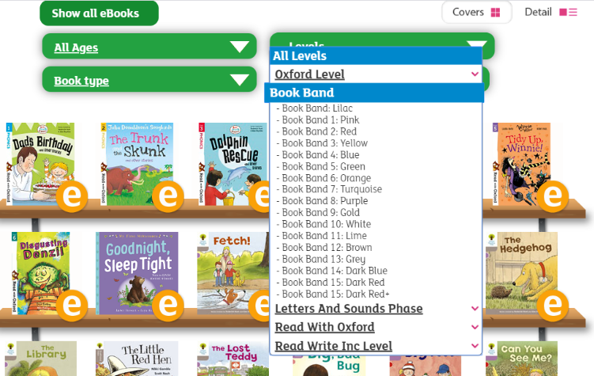
On this page, click where it says ‘levels’. This will open a drop-down menu – choose ‘book bands’ and then you should be able to click on your colour book band to see all the appropriate books.

Reading Comprehension
Each week I will also set a reading comprehension for you to do. It is really important that we keep practising using our comprehension skills as we have been working really hard on these. This week’s reading is a non-fiction text about costal erosion.

Read Write Inc Phonics
Daily Read Write Inc lessons restart this week on YouTube – we are focussing on Set 3 sounds, all lessons are now available at 9am each weekday morning.
https://www.youtube.com/channel/UCo7fbLgY2oA_cFCIg9GdxtQ/videos
It will be really beneficial if your child can watch these as it will have a really positive impact on their reading and writing once we are back at school.

