Class 6 – English
Week beginning 15th June 2020

Weekly spellings
This week your spellings are challenge words from the statutory spelling list.

Use the grid below to practise your spellings. Tick the columns as you follow the instructions from left to right. Make sure you spell the words in the column that is titled ‘write’. If you spell the word incorrectly write it again in the ‘correction’ column.
 | Look | Say | Cover | Write | Check | Correction
believe

appear

often

group

breath

continue

arrive

women

describe

height

Challenge – can you put each word in a sentence? If you are unsure of the meaning of any of the words the online dictionary on this website is really useful https://kids.wordsmyth.net/

Weekly English
This week is based around the The Queen of the Birds. Below is a summary of each day – each activity is explained further on the PDF document.
Monday
Listen to part of the story The Queen of the Birds, told by Wilf Merttens. Either predict what might next in the tale or write a recount of what happens in the second part of the story. Suggest how a competition to discover a Y3 class King or Queen might be organised.
Tuesday
Listen to the remaining part of Queen of the Birds. Identify and distinguish between homophones in a set of sentences. Identify and create similes to describe a wren.
Wednesday
Listen to a reading of The King of the Birds, written by Helen Ward. List the differences between the two versions of the tale. Correctly lay-out and punctuate a conversation between the eagle and the wren. There is a PowerPoint to go with this lesson.
Thursday
Listen again to King of the Birds. Learn and apply the rules on using the determiners a or an. Write a persuasive letter from a character in the story.
Friday
Read two poems, Owl and The Sparrow. Answer questions about each one. Select your favourite poem of the two and explain why you prefer it.

Reading
Please continue to read daily. If you have read all of the book that you brought home from school you can get lots of free e-books on the website:
https://www.oxfordowl.co.uk/for-home/find-a-book/library-page/#
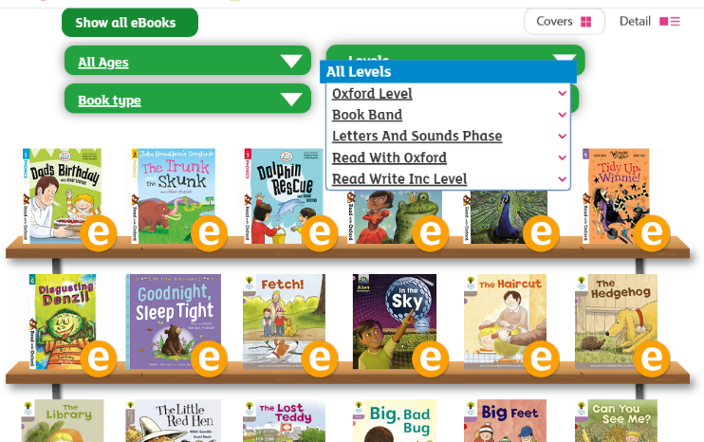
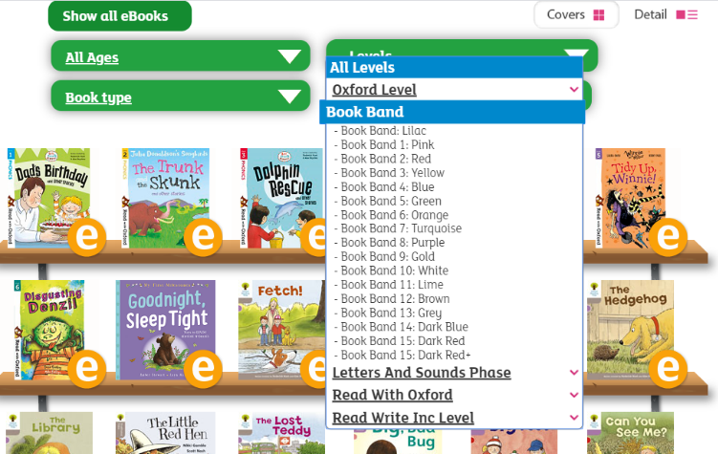
On this page, click where it says ‘levels’. This will open a drop-down menu – choose ‘book bands’ and then you should be able to click on your colour book band to see all the appropriate books.

Reading Comprehension
Each week I will also set a reading comprehension for you to do. It is really important that we keep practising using our comprehension skills as we have been working really hard on these. This week’s reading is a non-fiction text about the seaside.

Read Write Inc Phonics
Daily Read Write Inc lessons restart this week on YouTube – we are focussing on Set 3 sounds, all lessons are now available at 9am each weekday morning.
https://www.youtube.com/channel/UCo7fbLgY2oA_cFCIg9GdxtQ/videos
It will be really beneficial if your child can watch these as it will have a really positive impact on their reading and writing once we are back at school.

