Class 6 – English
Week beginning 8th June 2020

Weekly spellings
This week your spellings are more adverbs that use the suffix -ly

Use the grid below to practise your spellings. Tick the columns as you follow the instructions from left to right. Make sure you spell the words in the column that is titled ‘write’. If you spell the word incorrectly write it again in the ‘correction’ column.
 | Look | Say | Cover | Write | Check | Correction
truly

duly

wholly

fully

daily

publicly

dryly

slyly

shyly

coyly

Challenge – can you put each word in a sentence? If you are unsure of the meaning of any of the words the online dictionary on this website is really useful https://kids.wordsmyth.net/

Weekly English
This week is based around The Little Story That Didn’t Want To Be Told.
Below is a summary of each day – each activity is explained further on the PDF document.
Monday
Listen to Wilf Merttens The Little Story That Didn’t Want to Be Told. Explore how commas and the word and can be used to separate items in a list. Write imaginatively in response to a story, using commas in lists.
Tuesday
Re-listen to the story reading. Use descriptive language to write about a picture linked to the story. Use a selection of conjunctions to link together ideas in writing. Consider what makes for an effective story telling or reading.
Wednesday
Read a different version of The Little Story That Didn’t Want To Be Told and answer a series of comprehension questions about the story. Write descriptively about an animal linked to the story.
Thursday
Re-read The Little Story That Didn’t Want To Be Told. Work through the PowerPoint presentation outlining how to punctuate and lay out direct speech. Write a correctly punctuated and laid out conversation between two characters from the Little Story.
Friday
Summarise opinions and feelings about the different versions of The Little Tale. Plan and write a simple, three-part story featuring characters from the tale. Include punctuated direct speech and conjunctions in story writing.

Reading
Please continue to read daily. If you have read all of the book that you brought home from school you can get lots of free e-books on the website:
https://www.oxfordowl.co.uk/for-home/find-a-book/library-page/#
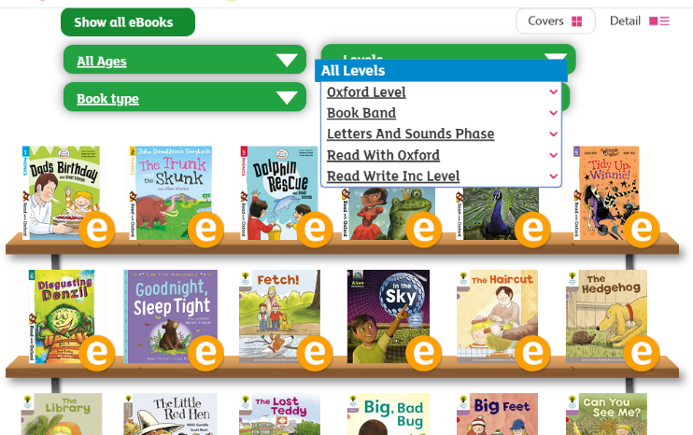
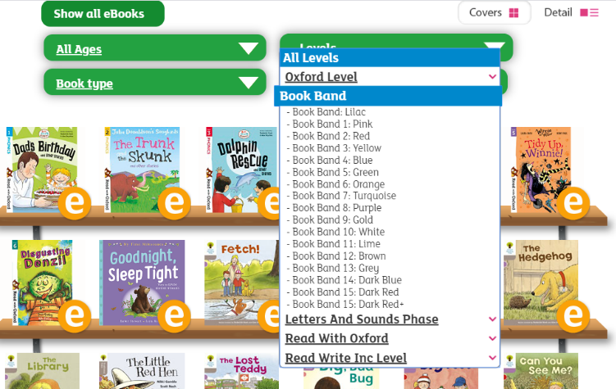
On this page, click where it says ‘levels’. This will open a drop-down menu – choose ‘book bands’ and then you should be able to click on your colour book band to see all the appropriate books.

Reading Comprehension
Each week I will also set a reading comprehension for you to do. It is really important that we keep practising using our comprehension skills as we have been working really hard on these. This week’s reading is a non-fiction text about the water cycle.

Read Write Inc Phonics
Daily Read Write Inc lessons restart this week on YouTube – we are focussing on Set 3 sounds, all lessons are now available at 9am each weekday morning.
https://www.youtube.com/channel/UCo7fbLgY2oA_cFCIg9GdxtQ/videos
It will be really beneficial if your child can watch these as it will have a really positive impact on their reading and writing once we are back at school.

