Class 6 – English
Week beginning 1st June 2020

Weekly spellings
This week your spellings are more adverbs that use the suffix -ly

Use the grid below to practise your spellings. Tick the columns as you follow the instructions from left to right. Make sure you spell the words in the column that is titled ‘write’. If you spell the word incorrectly write it again in the ‘correction’ column.
 | Look | Say | Cover | Write | Check | Correction
basically

frantically

dramatically

magically

tragically

comically

actually

accidentally

occasionally

eventually

Challenge – can you put each word in a sentence? If you are unsure of the meaning of any of the words the online dictionary on this website is really useful https://kids.wordsmyth.net/

Weekly English
This week is based around the The King of Rome and poetry. Below is a summary of each day – each activity is explained further on the PDF document.
Monday
Listen to the song, ‘The King of Rome’. Revise and practise direct speech and then make a version of the story. There is a PowerPoint to go with today’s work.
Tuesday
Write sentences that use synonyms for said and then write paragraphs to accompany illustrations from the story, ‘The King of Rome’.
Wednesday
Watch an animation of calligrams, ‘Bembo’s Zoo’. Investigate some designs and then make a calligram of your own design.
Thursday
Read a three-line poem arranged as a triangle. Practise using conjunctions to join clauses. Carefully handwrite your favourite verse of the poem.
Friday
Learn part of the poem by heart. Practise using prepositions to add phrases to clauses. Write your own triangular shaped poems.

Reading
Please continue to read daily. If you have read all of the book that you brought home from school you can get lots of free e-books on the website:
https://www.oxfordowl.co.uk/for-home/find-a-book/library-page/#
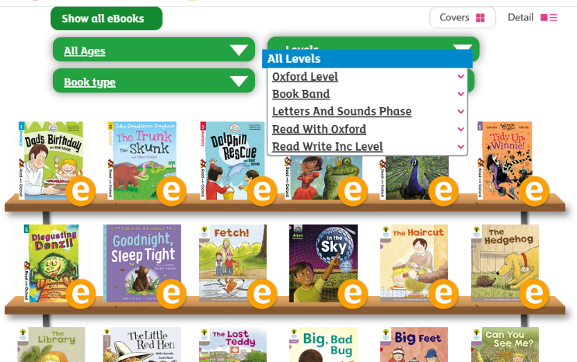
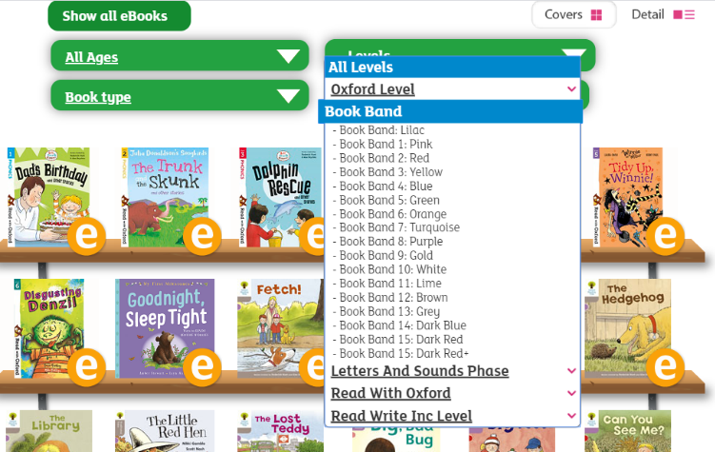
On this page, click where it says ‘levels’. This will open a drop-down menu – choose ‘book bands’ and then you should be able to click on your colour book band to see all the appropriate books.

Reading Comprehension
Each week I will also set a reading comprehension for you to do. It is really important that we keep practising using our comprehension skills as we have been working really hard on these. This week’s reading is a non-fiction text about Strange Predators.

Read Write Inc Phonics
Daily Read Write Inc lessons restart this week on YouTube – we are focussing on Set 3 sounds, all lessons are now available at 9am each weekday morning.
https://www.youtube.com/channel/UCo7fbLgY2oA_cFCIg9GdxtQ/videos
It will be really beneficial if your child can watch these as it will have a really positive impact on their reading and writing once we are back at school.

