Class 6 – English
Week beginning 25th May 2020

Weekly spellings
This week your spellings are more adverbs that use the suffix -ly

Use the grid below to practise your spellings. Tick the columns as you follow the instructions from left to right. Make sure you spell the words in the column that is titled ‘write’. If you spell the word incorrectly write it again in the ‘correction’ column.
 | Look | Say | Cover | Write | Check | Correction
gently

simply

humbly

nobly

horribly

terribly

possibly

incredibly

comfortably

probably

Challenge – can you put each word in a sentence? If you are unsure of the meaning of any of the words the online dictionary on this website is really useful https://kids.wordsmyth.net/

Weekly English
This week is based around the Sword in the Stone and poems by Robert Louis Stevenson. Below is a summary of each day – each activity is explained further on the PDF document.
Monday
Listen to a reading of the book, ‘King in the Sky’. Read extracts and answer questions. Write descriptions of settings and of a view from your home.
Tuesday
Listen again to ‘King of the Sky’. Write about the two main characters. Write speech in speech bubbles and direct speech. There is a PowerPoint to go with today’s work.
Wednesday
Watch the start of a film about pigeon racing and compare it to ‘King of the Sky’. Read and sort information about pigeons. Research the war pigeon – Mary of Exeter.
Thursday
Read ‘The Cow’ by Robert Louis Stevenson. Practise using adverbs. Learn some or all of the poem by heart. There is a PowerPoint to go with today’s work.
Friday
Read ‘Sheep in Winter’. Practise using adverbs. Read other poems and choose one to practise reading aloud.

Reading
Please continue to read daily. If you have read all of the book that you brought home from school you can get lots of free e-books on the website:
https://www.oxfordowl.co.uk/for-home/find-a-book/library-page/#
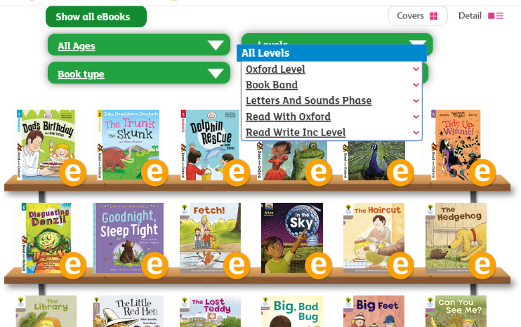
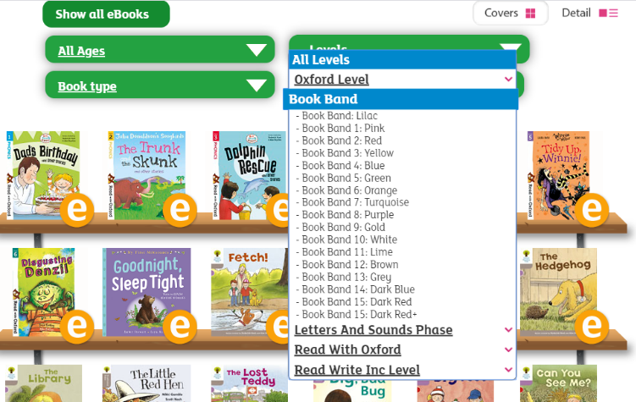
On this page, click where it says ‘levels’. This will open a drop-down menu – choose ‘book bands’ and then you should be able to click on your colour book band to see all the appropriate books.

Reading Comprehension
Each week I will also set a reading comprehension for you to do. It is really important that we keep practising using our comprehension skills as we have been working really hard on these. This week’s reading is a traditional tale from Australia.

