Class 6 – English
Week beginning 18th May 2020

Weekly spellings
This week your spellings are more adverbs that use the suffix -ly

Use the grid below to practise your spellings. Tick the columns as you follow the instructions from left to right. Make sure you spell the words in the column that is titled ‘write’. If you spell the word incorrectly write it again in the ‘correction’ column.
 | Look | Say | Cover | Write | Check | Correction
happily

angrily

lazily

easily

busily

greedily

messily

wearily

cheekily

clumsily

Challenge – can you put each word in a sentence? If you are unsure of the meaning of any of the words the online dictionary on this website is really useful https://kids.wordsmyth.net/

Weekly English
This week is based around the Sword in the Stone and poems by Robert Louis Stevenson. Below is a summary of each day – each activity is explained further on the PDF document.
Monday
Listen to a version of the Sword in the Stone. Read a different version of the story in print and answer questions before making a map of the characters.
Tuesday
Watch a version of Sword in the Stone. Choose part of the story to write, improving given sentences to write a paragraph. Make a story summary and use it to tell the whole story.
Wednesday
Beginning work on different forms of past tense. There is a PowerPoint presentation to help you with this. If you click the speaker symbol in the top left corner there is sound to go with it. Read ‘A Good Play’ by Robert Louis Stevenson. Practise past and present tense and then write creatively.
Thursday
Read ‘The Swing’ by Robert Louis Stevenson. Practise progressive form and write about your own play. There is a PowerPoint to help you with this.
Friday
Read ‘Where Go the Boats’. Practise the perfect form then choose your favourite poem and memorise it. There is a PowerPoint to help you with this.

Reading
Please continue to read daily. If you have read all of the book that you brought home from school you can get lots of free e-books on the website:
https://www.oxfordowl.co.uk/for-home/find-a-book/library-page/#
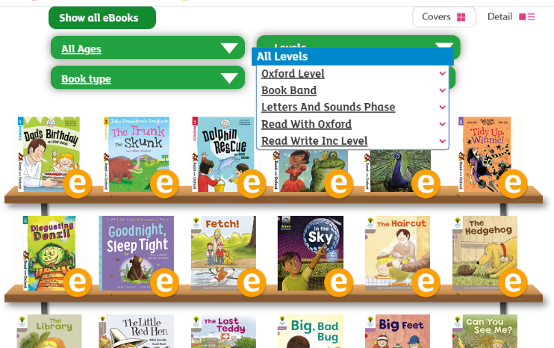
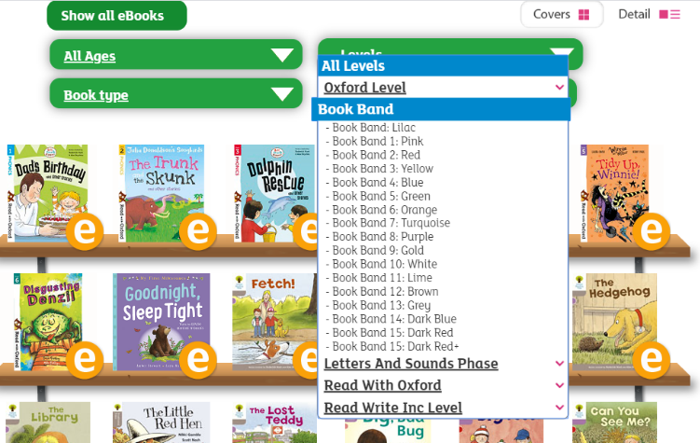
On this page, click where it says ‘levels’. This will open a drop-down menu – choose ‘book bands’ and then you should be able to click on your colour book band to see all the appropriate books.

Reading Comprehension
Each week I will also set a reading comprehension for you to do. It is really important that we keep practising using our comprehension skills as we have been working really hard on these. This week’s reading is a traditional tale from Australia.

Read Write Inc Phonics
Daily Read Write Inc lessons continue this week on YouTube – we are focussing on Set 3 sounds, the lesson for this is at 10.30 am each weekday morning.
https://www.youtube.com/channel/UCo7fbLgY2oA_cFCIg9GdxtQ/videos
It will be really beneficial if your child can watch these as it will have a really positive impact on their reading and writing once we are back at school.

