Class 6 – English
Week beginning 11th May 2020

Weekly spellings
This week your spellings are all adverbs that use the suffix -ly

Use the grid below to practise your spellings. Tick the columns as you follow the instructions from left to right. Make sure you spell the words in the column that is titled ‘write’. If you spell the word incorrectly write it again in the ‘correction’ column.
 | Look | Say | Cover | Write | Check | Correction
kindly

quickly

safely

rudely

sweetly

strongly

bravely

secretly

finally

usually

Challenge – can you put each word in a sentence? If you are unsure of the meaning of any of the words the online dictionary on this website is really useful https://kids.wordsmyth.net/

Weekly English
This week is based around word classes and poetry. Below is a summary of each day – each activity is explained further on the PDF document.

Monday
Read profiles of video-game characters and sort words into classes. Write sentences and highlight different word classes. There is a PowerPoint presentation to help you with this. If you click the speaker symbol in the top left corner there is sound to go with it.
Tuesday
Label a picture of new Mario-style characters. Practise using word classes to write sentences about the characters and then make up a story including adverbs and adjectives.
Wednesday
Read a dictionary extract and identify its different parts, including word class and meaning. Research given words using an online dictionary and write entries for three of them. Write sentences or a story using your words.
Thursday
Think carefully about a photograph of some pets. Read a poem and answer reflective questions. Read a set of poems and make notes about them.
Friday
Read a poem and answer reflective questions. Revise metaphors and similes and practise creating these for pets. Plan and write a poem about a pet.

Reading
Please continue to read daily. If you have read all of the book that you brought home from school you can get lots of free e-books on the website:
https://www.oxfordowl.co.uk/for-home/find-a-book/library-page/#
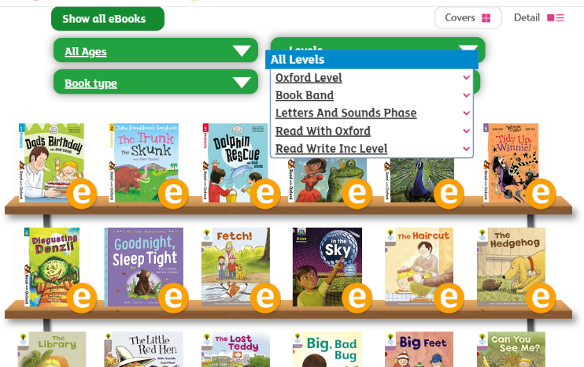
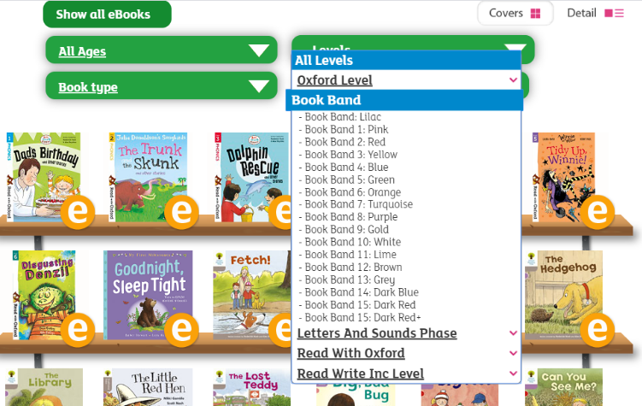
On this page, click where it says ‘levels’. This will open a drop-down menu – choose ‘book bands’ and then you should be able to click on your colour book band to see all the appropriate books.

Reading Comprehension
Each week I will also set a reading comprehension for you to do. It is really important that we keep practising using our comprehension skills as we have been working really hard on these. This week’s reading is a traditional tale from Australia.

Read Write Inc Phonics
Daily Read Write Inc lessons continue this week on YouTube – we are focussing on Set 3 sounds, the lesson for this is at 10.30 am each weekday morning.
https://www.youtube.com/channel/UCo7fbLgY2oA_cFCIg9GdxtQ/videos
It will be really beneficial if your child can watch these as it will have a really positive impact on their reading and writing once we are back at school.

