Class 6 – English
Week beginning 4th May 2020

Weekly spellings
This week your spellings are all word families based on root words ‘press’ and ‘vent’

Use the grid below to practise your spellings. Tick the columns as you follow the instructions from left to right. Make sure you spell the words in the column that is titled ‘write’. If you spell the word incorrectly write it again in the ‘correction’ column.
 | Look | Say | Cover | Write | Check | Correction
press

suppress

express

compress

impress

prevent

invent

venture

adventure

eventful

Challenge – can you put each word in a sentence? If you are unsure of the meaning of any of the words the online dictionary on this website is really useful https://kids.wordsmyth.net/

Weekly English
This week is based on Harry Potter. Below is a summary of each day – each activity is explained further on the PDF document.

Monday
Read an extract about The Sorting Hat and practise using conjunctions to join clauses. There is a PowerPoint presentation to help you with this. If you click the speaker symbol in the top left corner there is sound to go with it.
Tuesday
Read another extract about The Sorting Hat. Practise using clauses and conjunctions.
Wednesday
Read an extract about the first broomstick lesson. Reflect on likely feelings at different parts of the story and write about taking part, using conjunctions.
Thursday
Read an extract about Quidditch and practise using adverbs. There is a PowerPoint presentation to help you with this. If you click the speaker symbol in the top left corner there is sound to go with it.
Friday
Read an extract about Neville Longbottom. Read an imagined school report and write one for yourself or somebody else.

Reading
Please continue to read daily. If you have read all of the book that you brought home from school you can get lots of free e-books on the website:
https://www.oxfordowl.co.uk/for-home/find-a-book/library-page/#
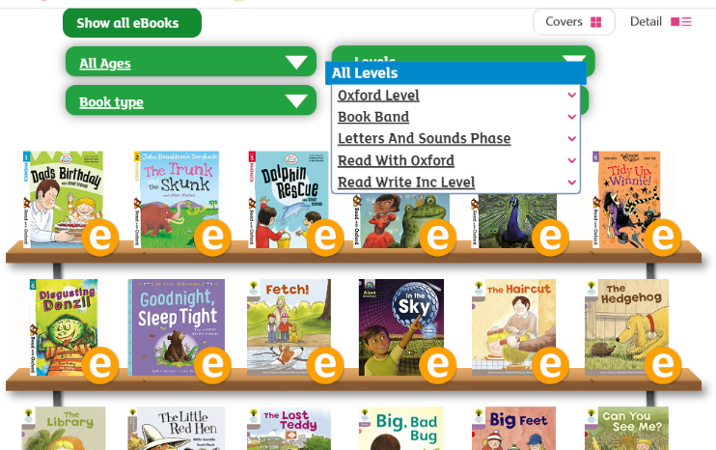
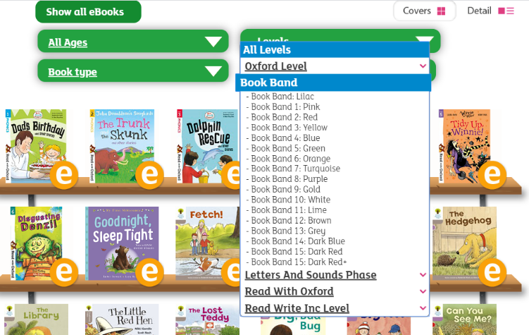
On this page, click where it says ‘levels’. This will open a drop-down menu – choose ‘book bands’ and then you should be able to click on your colour book band to see all the appropriate books.

Reading Comprehension
Each week I will also set a reading comprehension for you to do. It is really important that we keep practising using our comprehension skills as we have been working really hard on these. This week’s reading is a traditional tale from Australia.

Read Write Inc Phonics
Daily Read Write Inc lessons continue this week on YouTube – we are focussing on Set 3 sounds, the lesson for this is at 10.30 am each weekday morning.
https://www.youtube.com/channel/UCo7fbLgY2oA_cFCIg9GdxtQ/videos
It will be really beneficial if your child can watch these as it will have a really positive impact on their reading and writing once we are back at school.

