Class 6 – English
Week beginning 27th April 2020

Weekly spellings
This week your spellings are all word families based on root words ‘scop’ and ‘spect’

Use the grid below to practise your spellings. Tick the columns as you follow the instructions from left to right. Make sure you spell the words in the column that is titled ‘write’. If you spell the word incorrectly write it again in the ‘correction’ column.
 | Look | Say | Cover | Write | Check | Correction
scope

telescope

microscope

horoscope

periscope

inspect

spectator

respect

perspective

spectacles

Challenge – can you put each word in a sentence? If you are unsure of the meaning of any of the words the online dictionary on this website is really useful https://kids.wordsmyth.net/

Weekly English
This week we are continuing looking at reports and doing some grammar work focussing on direct speech. Below is a summary of each day – each activity is explained further on the PDF document.

Monday
Read a version of King Midas and the Donkey Ears. Order and illustrate the events and tell the story to somebody else. Then answer questions about the characters in the story.
Tuesday
Re-read the story and then punctuate the provided speech - there is a PowerPoint presentation to help you with this. If you click the speaker symbol in the top left corner there is sound to go with it.
Wednesday
Read a version of King Midas and the Golden Touch and make a summary of the story. Imagine a conversation from the story and then write it as properly punctuated direct speech.
Thursday
Read a description of the Harry Potter Studio Tour and make notes about the report. Explore a website and make further notes about your own preferences and choices.
Friday
Read two contrasting reviews of visits to the Harry Potter Studio. Speculate about the writers of the reviews and then write your own review about a brilliant or an awful day out.

Reading
Please continue to read daily. If you have read all of the book that you brought home from school you can get lots of free e-books on the website:
https://www.oxfordowl.co.uk/for-home/find-a-book/library-page/#
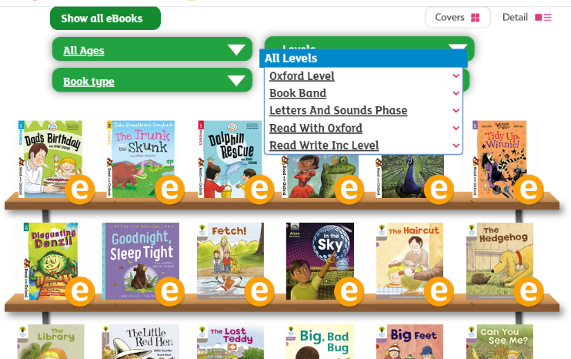
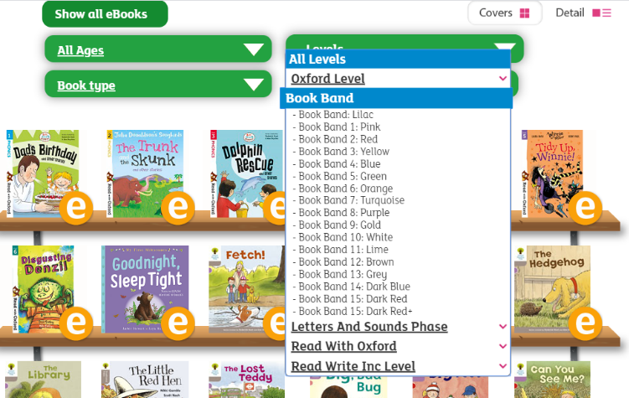
On this page, click where it says ‘levels’. This will open a drop-down menu – choose ‘book bands’ and then you should be able to click on your colour book band to see all the appropriate books.

Reading Comprehension
Each week I will also set a reading comprehension for you to do. It is really important that we keep practising using our comprehension skills as we have been working really hard on these. This week’s reading is a traditional tale from Australia.

Read Write Inc Phonics
Daily Read Write Inc lessons continue this week on YouTube – we are focussing on Set 3 sounds, the lesson for this is at 10.30 am each weekday morning.
https://www.youtube.com/channel/UCo7fbLgY2oA_cFCIg9GdxtQ/videos
It will be really beneficial if your child can watch these as it will have a really positive impact on their reading and writing once we are back at school.

