Class 6 – English
Week beginning 20th April 2020

Weekly spellings
This week your spellings are all word families based on root words ‘struct’ and ‘uni’

Use the grid below to practise your spellings. Tick the columns as you follow the instructions from left to right. Make sure you spell the words in the column that is titled ‘write’. If you spell the word incorrectly write it again in the ‘correction’ column.
 | Look | Say | Cover | Write | Check | Correction
instruct

structure

construction

instruction

instructor

unit

union

united

universe

university

Challenge – can you put each word in a sentence? If you are unsure of the meaning of any of the words the online dictionary on this website is really useful https://kids.wordsmyth.net/

Weekly English
This week we are looking at reports and doing some grammar work. Below is a summary of each day – each activity is explained further on the PDF document.

Monday
Read a report about Lego Star Wars and revise features of reports.
Tuesday
Continue looking at the features of reports, play some games on CBeebies and write a report about one of them.
Wednesday
Looking at present and past tense - there is a PowerPoint presentation to help you with this. If you click the speaker symbol in the top left corner there is sound to go with it. Read a fun poem and use the template to write your own.
Thursday
Progressive form of verbs – there is a PowerPoint presentation to help you with this. It has sound again like the one yesterday.
Friday
Perfect form of verbs – there is a PowerPoint presentation again to help you with this. Identify perfect form and then use this in writing your own version of a poem.

Reading
Please continue to read daily. If you have read all of the book that you brought home from school you can get lots of free e-books on the website:
https://www.oxfordowl.co.uk/for-home/find-a-book/library-page/#
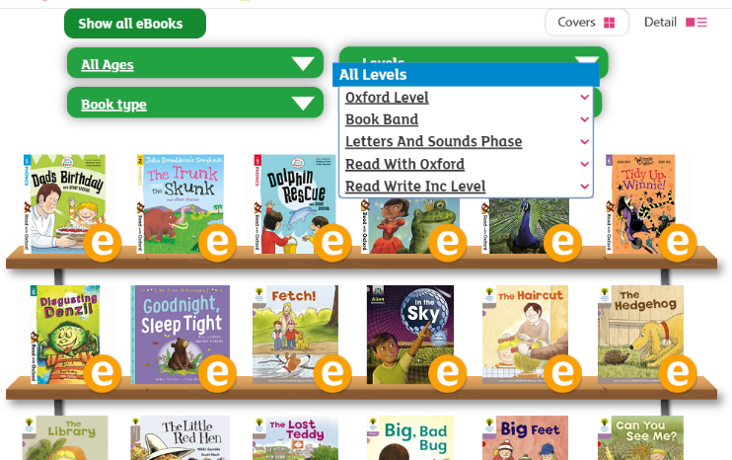
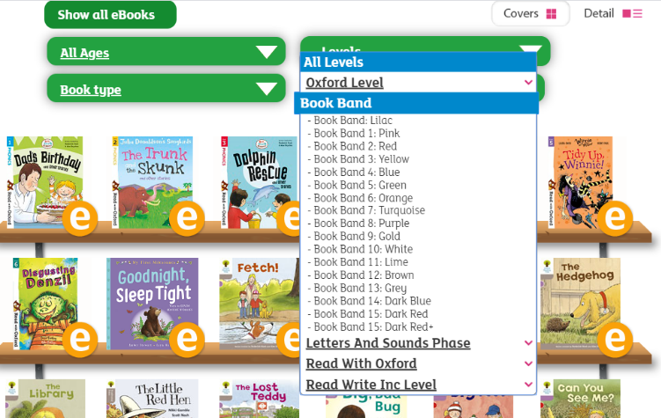
On this page, click where it says ‘levels’. This will open a drop-down menu – choose ‘book bands’ and then you should be able to click on your colour book band to see all the appropriate books.

Reading Comprehension
Each week I will also set a reading comprehension for you to do. It is really important that we keep practising using our comprehension skills as we have been working really hard on these. This week’s reading is a traditional tale from Australia.

Read Write Inc Phonics
Daily Read Write Inc lessons start this week on YouTube – we are focussing on Set 3 sounds, the lesson for this is at 10.30 am each weekday morning.
https://www.youtube.com/channel/UCo7fbLgY2oA_cFCIg9GdxtQ/videos
It will be really beneficial if your child can watch these as it will have a really positive impact on their reading and writing once we are back at school.

