Class 6 – English
Week beginning 13th April 2020

Weekly spellings
This week your spellings are all words with a short /u/ sound spelt with ‘ou’.

Use the grid below to practise your spellings. Tick the columns as you follow the instructions from left to right. Make sure you spell the words in the column that is titled ‘write’. If you spell the word incorrectly write it again in the ‘correction’ column.
 | Look | Say | Cover | Write | Check | Correction
enough

young

touch

double

trouble

country

courage

rough

tough

cousin

Challenge – can you put each word in a sentence? If you are unsure of the meaning of any of the words the online dictionary on this website is really useful https://kids.wordsmyth.net/

Weekly English
This week we are looking at the Fantastic Mr Fox story and doing some grammar work. Below is a summary of each day – each activity is explained further on the PDF document.

Monday
Read the first 2 chapters of Fantastic Mr Fox and complete activities relating to the characters.
Tuesday
Present perfect forms of past tense – there is a PowerPoint presentation to help you with this. If you click the speaker symbol in the top left corner there is sound to go with it.
Wednesday
Writing a story along similar lines of Fantastic Mr Fox.
Thursday
Prepositions – there is a PowerPoint presentation to help you with this. It has sound again like the one on Tuesday. There is a story about dyes to go with today’s work.
Friday
Continuing with prepositions from yesterday.

Reading
Please continue to read daily. If you have read all of the book that you brought home from school you can get lots of free e-books on the website:
https://www.oxfordowl.co.uk/for-home/find-a-book/library-page/#
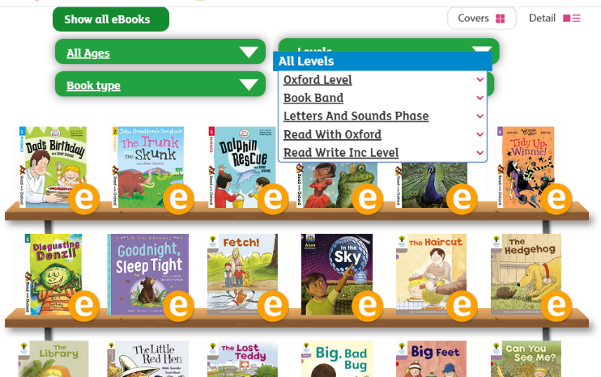
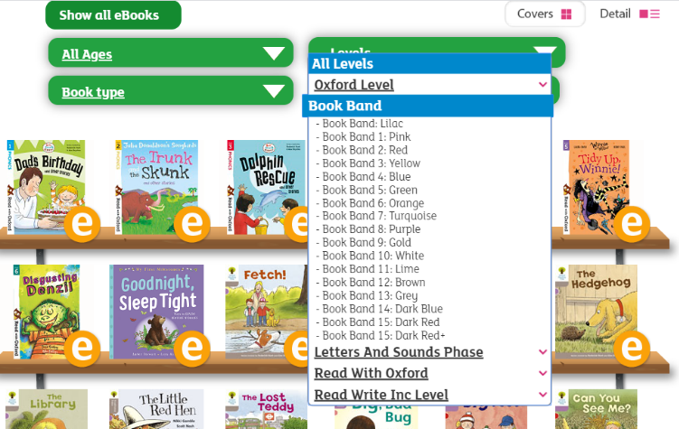
On this page, click where it says ‘levels’. This will open a drop-down menu – choose ‘book bands’ and then you should be able to click on your colour book band to see all the appropriate books.

Reading Comprehension
Each week I will also set a reading comprehension for you to do. It is really important that we keep practising using our comprehension skills as we have been working really hard on these.

Read Write Inc Phonics
From April 20th there will be daily Read Write Inc lessons on YouTube – I will send the link for these nearer the time but until then you can catch up on the speed sounds that have been done so far. https://www.youtube.com/channel/UCo7fbLgY2oA_cFCIg9GdxtQ/videos This link will take you to the page with all the videos on, or you can go to YouTube and search ‘Ruth Miskin’ which will also take you to the correct page. We are focusing on the Set 3 sounds as a class. Some children who go to Read Write Inc groups may recognise that they are on a different set and the videos for the other sets are on here too. There are also some lovely stories that you can listen to with your children.

