Class 6 – English
Week beginning 6th April 2020

Weekly spellings
This week your spellings are all words that have a short /u/ sound spelt with ‘o’.
Use the grid below to practise your spellings. Tick the columns as you follow the instructions from left to right. Make sure you spell the words in the column that is titled ‘write’. If you spell the word incorrectly write it again in the ‘correction’ column.
 | Look | Say | Cover | Write | Check | Correction
woman

wonder

month

govern

brother

another

shovel

above

Monday

discover

Challenge – can you put each word in a sentence? If you are unsure of the meaning of any of the words the online dictionary on this website is really useful https://kids.wordsmyth.net/

Weekly English – Greek Myths and Poetry
This week we will be looking at the Greek and poetry. You will need to begin by reading the story of Icarus and then there are 5 daily lessons with activities for you to complete.

As with the maths, I would love to see what you have been doing. I will be checking the Class Dojo app so it would be great if you could send me some photos. I will also be recording myself reading the texts that are given each day, starting with the Icarus story, just like I would if we were still in school.

Reading
Please continue to read daily. If you have read all of the book that you brought home from school you can get lots of free e-books on the website:
https://www.oxfordowl.co.uk/for-home/find-a-book/library-page/#
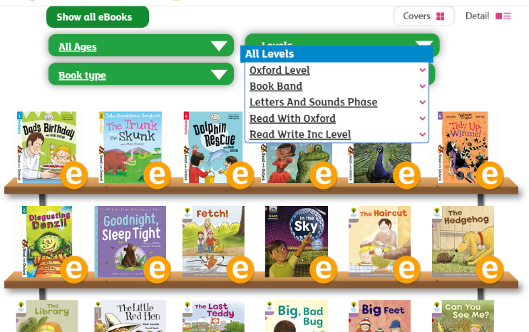
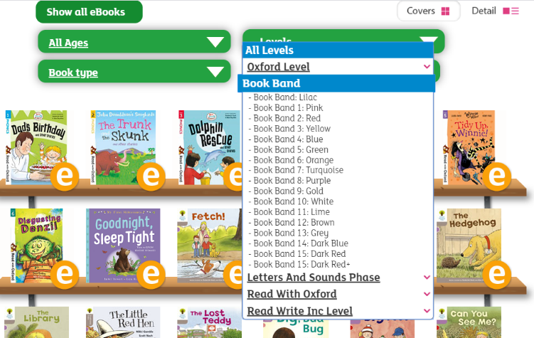
On this page, click where it says ‘levels’. This will open a drop-down menu – choose ‘book bands’ and then you should be able to click on your colour book band to see all the appropriate books.

Reading Comprehension
Each week I will also set a reading comprehension for you to do. It is really important that we keep practising using our comprehension skills as we have been working really hard on these.

