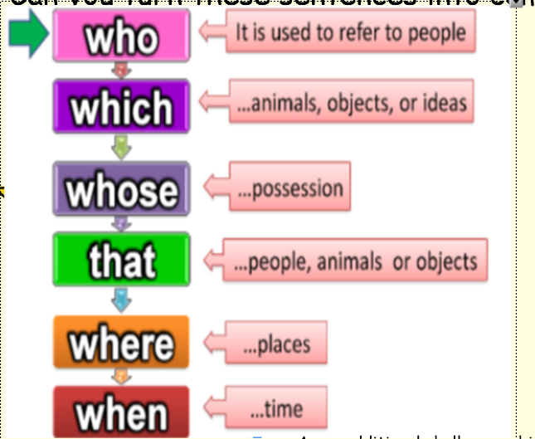
Can you take the two simple sentences below and turn them into a complex sentence?
Example:
Michael played his guitar. He was in his room.

Michael, who was in his room, played his guitar.

- The Giant Redwoods are the tallest trees in the world. They grow more than 350ft. (which)

- The Giant Redwoods, which grow more than 350 ft, are the tallest trees in the world.

- The sun shone brightly over the forest. It dazzled like a sparkling gem. (which)

- The children laughed softly. They were playing amongst the trees. (who)

- The wind blew ferociously through the enormous branches. It howled like a wolf in winter. (which)

