Class 6 – Useful Websites
Here are some websites that I think could be really useful if you have access to the internet.

Keeping active is really important for both your body and your mind. Here are some websites which can help you to keep active:
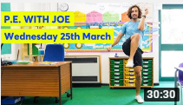
PE with Joe – www.youtube.com
When you get onto YouTube search PE with Joe – he does a daily workout at 9am but they are then saved on his page so you can access them whenever you want to.
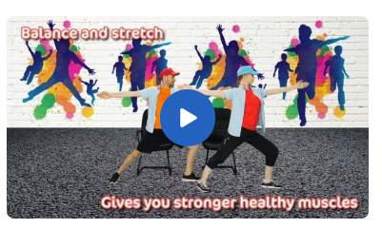
Imoves – join.theimovement.com
You will have to get a grown up to sign up for free but once you are signed up there are lots of videos including a daily activity, follow up educational activities, meditation videos and quick blasts so there is something for everyone!

Cosmic Kids Yoga - https://www.youtube.com/user/CosmicKidsYoga
Fun yoga and mindfulness using stories and cool characters.

It is important to keep reading – here are some useful websites for reading and book related activities:
The Reading Realm - https://thereadingrealm.co.uk/

This is great! They do a live daily lesson on their Facebook group at 11 am (www.facebook.com/groups/542651952902400/) which is linked to popular stories and poems and then has activities on the website to go with the lesson. The activities include drama, art, quizzes and much more!

British Library Discovering Children’s Books – type this into Google and click the first link. Lots of creative activities linked to books including making your own mini book and learning how to draw a Gruffalo.


Draw with Rob – http://www.robbiddulph.com/draw-with-rob
Author and illustrator Rob Biddulph is doing a live draw along video every Tuesday and Thursday at 10am but these are then saved on his website so you can watch them when you have time. He will teach you how to draw lots of different amazing characters.

Oxford Owls - https://home.oxfordowl.co.uk/books/free-ebooks/
Lots of free eBooks so that you can keep reading at home! You will need a grown up to register for free on the website before you can read the books.

White Rose Maths – https://whiterosemaths.com/homelearning/year-3/
You will have your maths that I set to complete each week but if you want some extra to do this is a fantastic site. They have daily lessons with a video teaching you about an area of maths and activities to complete.

TTS - https://www.tts-group.co.uk/home+learning+activities.html
Some ready-made home learning packs with lots of different activities that you can download for free.

