SCIENCE
Animals including humans
Food Chains
Follow the link below:
https://www.bbc.co.uk/bitesize/articles/zhnny9q

Session 1:
- Watch the video clip about food chains
- Read the information about producers and consumers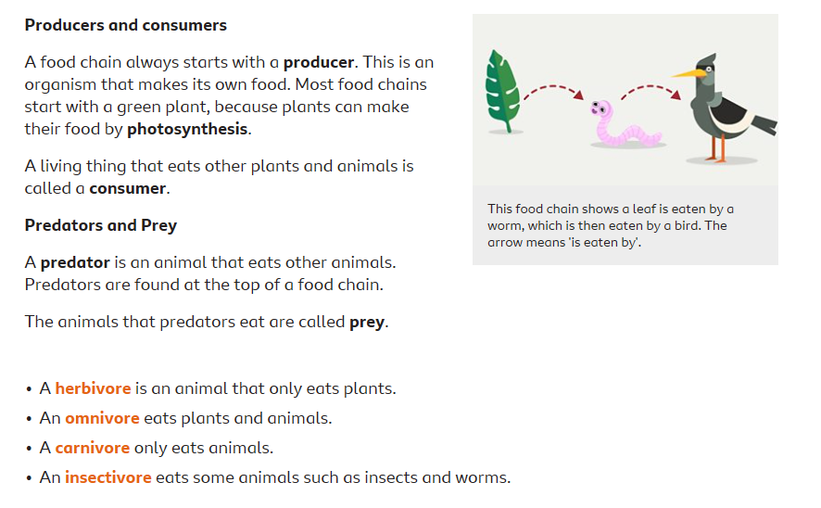
- Complete the 3 ‘Food Chain Challenge’ activities (Savannah, Tunda, Woodland)

Session 2:
Using your knowledge from session 1 this week, complete the following activities (still on the same link as above)
- ‘Reorder’ – Put the food chain in the correct order
- Food chain quiz

