
Scratch – Lesson 5
Name:

Explain what this code will do:
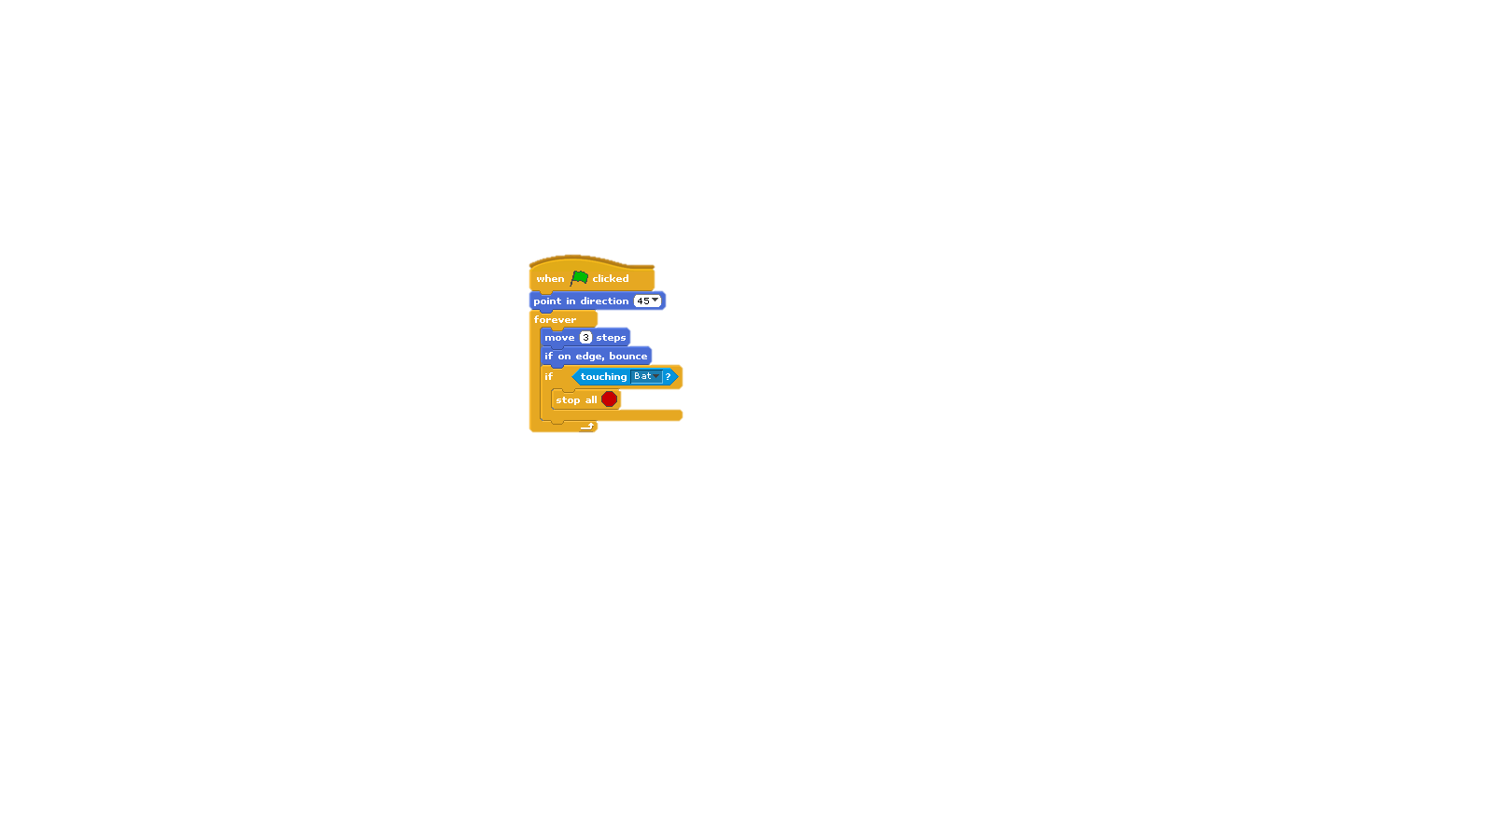
Mark on the grid where the letters will appear:
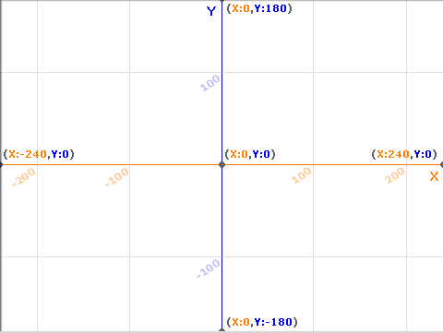
Letter | X position | Y position
A | 0 | 0
B | 240 | 180
C | 0 | -180
D | -100 | 100
E | 50 | -100

