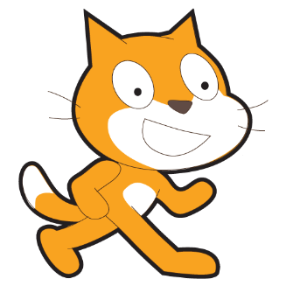
Scratch – Lesson 6
Name:

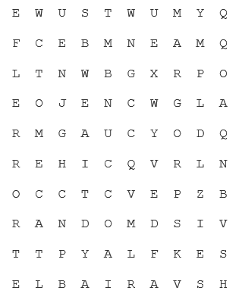
CHANGE | ERROR | LOGIC
PROGRAM | RANDOM | SEQUENCE
SET | VARIABLE

True or False?
A “variable” can only save numbers.
 | True |  | False
You can change the value in a variable.
 | True |  | False
The “random” script can be found in the “control” group.
 | True |  | False
You can see if a value is higher or lower than another value using the “operator” group.
 | True |  | False

