
Scratch – Lesson 3
Name:

 | Questions to answer

Describe what each of these lines of code do.

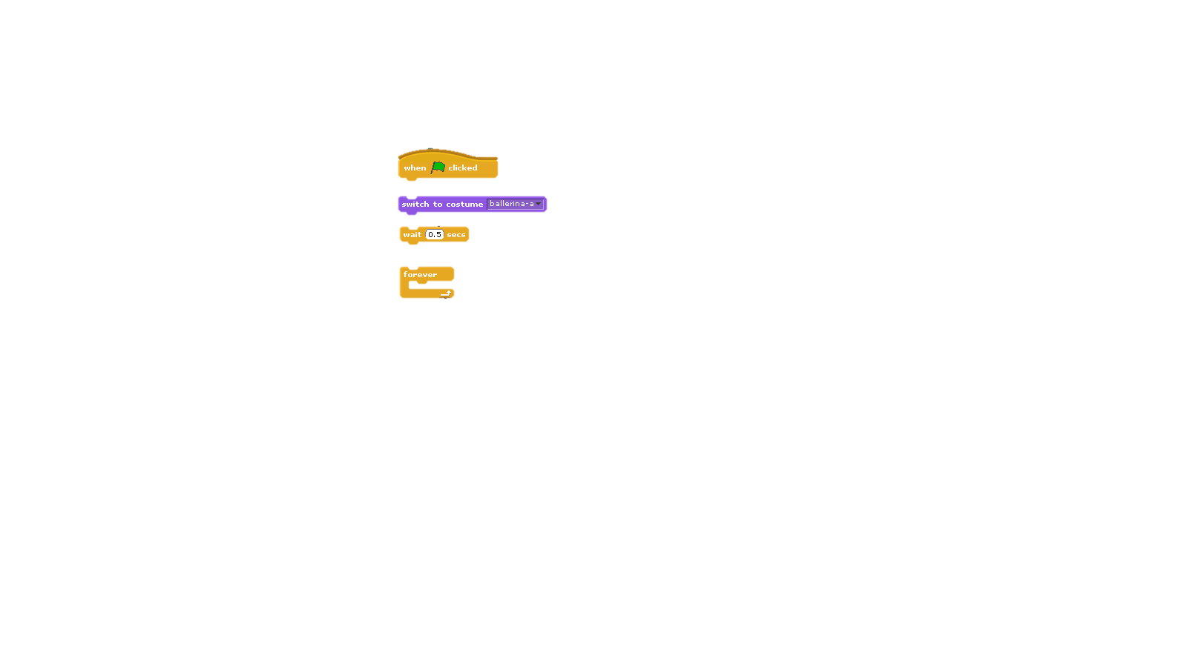

Use the space below to describe how the program you have written works.

___________________________________________________________

___________________________________________________________

___________________________________________________________

___________________________________________________________

___________________________________________________________

___________________________________________________________

___________________________________________________________

___________________________________________________________

___________________________________________________________

___________________________________________________________

